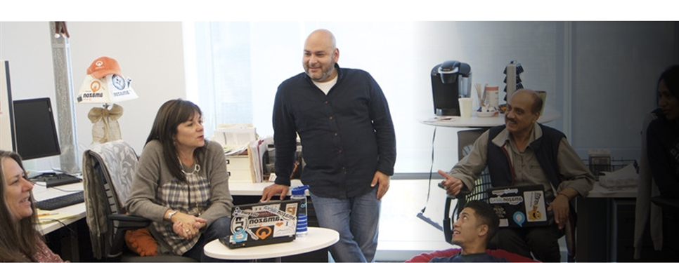

# Level-up CSP Technical Training – Power Platform

**Use case – Automate Employee Onboarding using Power Platform**

|  |  |
| --- | --- |
| Description | A hands-on experience to inspire users to use Microsoft Power Platform tools to design and implement digital systems to meet business objectives. |
| Prerequisites | To get the most out of this training we recommend you have admin access with Power Apps for Developer and Power Automate. |
| Audience | Microsoft partners will deliver this workshop to CSP customers, who have multiple employees in their company, have a Microsoft Power Apps for Developer and Microsoft Power Automate license, and have minimal Microsoft Power Platform experience. |
| Duration | 60 minutes |
| Publication date | September 2024 |

This document is provided “as-is”. Information and views expressed in this document, including URL and other Internet Web site references, may change without notice. You bear the risk of using it.

This document does not provide you with any legal rights to any intellectual property in any Microsoft product. You may copy and use this document for your internal reference purposes.

© 2024 Microsoft. All rights reserved.

Contents

Level-up CSP Technical Training – Power Platform 1

Objective and scenario 4

Objective 4

Solution focus area 4

Personas and scenario 4

Pre-requisites 5

Lab instructions 6

Exercise 1: Create Employees, HR and Manager list in Share point. 6

Task 1: Verifying your Dataverse environment 6

Task 2: Create a site in SharePoint 6

Task 3: Create an Employees list in SharePoint site from CSV file 12

Task 4: Create a HR list in SharePoint site from CSV file 23

Conclusion 28

Exercise 2: Create Power Apps for SharePoint Lists 28

Task 1: Customize Employee form with PowerApps for HRs to fill. 28

Task 2: Create employee onboarding Canvas app for the employee 48

Task 3: Create Power Automate flow to send a form to the new employee 69

Task 4: Test the flow. 78

Conclusion 82

# Objective and scenario

## Objective

Develop an app to onboard employees automatically.

## Solution focus area

Contoso Corp is a mid-sized technology company specializing in software development and IT consulting. The company values innovation, collaboration, and employee development. To streamline the onboarding process for new hires, Contoso Corp has decided to develop an automated process which will welcome the new hires, get their documents submitted and schedule their orientation.

By implementing this automated onboarding process, Contoso Corp aims to create a seamless transition for new employees, allowing them to focus on their roles and contribute to the mission of driving innovation in the technology sector. Contoso believes that a well-structured onboarding experience not only enhances employee satisfaction but also boosts overall productivity and engagement.

Contoso Corp needs a new solution that can:

* To create a seamless onboarding process,
* Design a comprehensive program that ensures new hires feel welcomed, informed, and equipped to succeed in their roles.

Based on the above requirements, you have decided to leverage Microsoft Power Platform tools, including Power Apps and Power Automate to enhance the onboarding experience at Contoso Corp.

## Personas and scenario

* **Remy Morris** - Digital Solutions Architect
* **Mark Brown** – Project lead
* **David Flores** – App developer
* **Jane Miller** – App tester

These personas will participate in the following sequential scenarios:

* Remy Morris, Digital Solutions Architect at Contoso Corp, creates and plans digital architecture that aligns with the business need and articulates this framework to Mark Brown, the Project Lead at Contoso Corp, and assists him in selecting the most suitable Power Platform tools for the implementation of the digital solutions.
* Mark Brown provides David Flores with an overview of the tools and processes involved in developing a canvas app using Power Apps and creating an approval flow using Power Automate.
* David successfully creates a canvas app and an approval flow, fulfilling all the requirements of Contoso Corp to streamline and automate the approval workflow for Employee Onboarding app, which he then submits to Jane Miller for testing.
* After thorough testing and validation, Mark Brown officially hands over the app to the team, enabling them to Onboard new employee efficiently.

# Pre-requisites

For this use case, all participants will need the following:

* Work, School or Admin Tenant Email Id and Password (To acquire Microsoft 365 Admin trial tenant, go to [Microsoft 365 E3](https://www.microsoft.com/en-us/microsoft-365/enterprise/e3?activetab=pivot%3Aoverviewtab%2F%3Fazure-portal%3Dtrue))
* [Microsoft Power Apps for Developer license](https://www.microsoft.com/en-in/power-platform/products/power-apps/free) (Includes Power Automate License)
* [Microsoft 365 Business Premium/E3/E5 license](https://www.microsoft.com/en-in/microsoft-365/business)
* Their own devices with Wi-Fi connection.

**Note**

Please be aware that the user interface (UI) of Power Apps, Power Automate, and other related tools may change over time as Microsoft continues to update its products. However, the core concepts and logic behind their functionality will remain consistent. The principles you learn in this lab can still be applied, even if the UI looks different in the future.

# Lab instructions

# Exercise 1: Create Employees, HR and Manager list in Share point.

In this exercise, you will create a Lists in SharePoint, and which will have employee information.

## Task 1: Verifying your Dataverse environment

* 1. Open a browser and go to <https://admin.powerplatform.microsoft.com>. Sign in with your work /school/admin account.
  2. Select **Environments** on the left navigation. The **Developer environment** should have been created for you as shown in the image below. (This environment is created automatically as soon as you provide Microsoft Power app for Developer license using your work/school accounts. The name of the environment will be different for every admin account.)

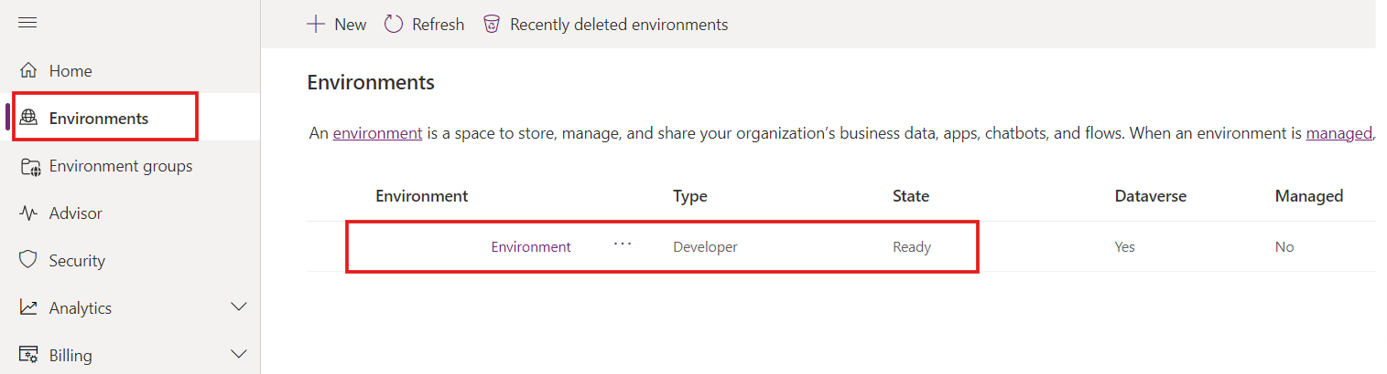

* 1. Use the same developer environment to execute all the exercises of this lab.

## Task 2: Create a site in SharePoint

1. Navigate to [Power Apps Maker Portal](https://make.powerapps.com/) or https:\\office.com and sign in with your office 365 tenant.
2. Click on matrix in the upper-left corner and select **SharePoint** from list of **apps**.

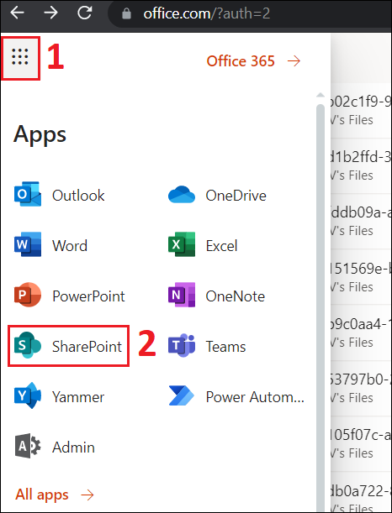 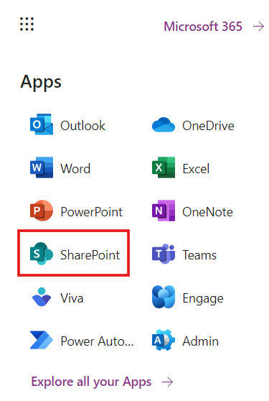

1. Click on **+Create site** on top menu.

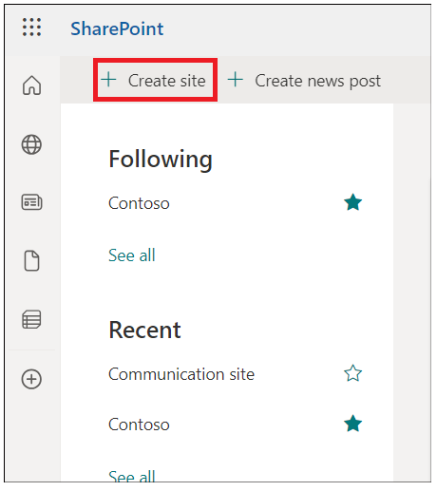

1. Select **Communication site** tile in **Create a site** window.

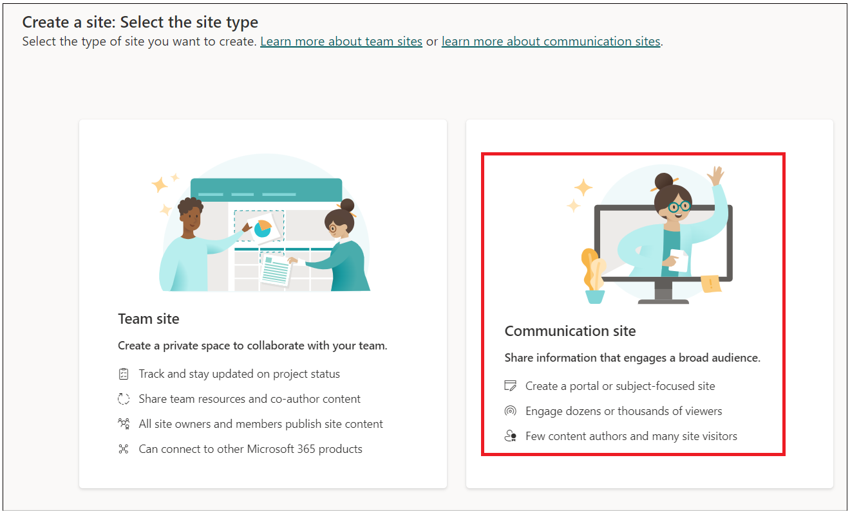

1. Scroll down and select **Blank** template.

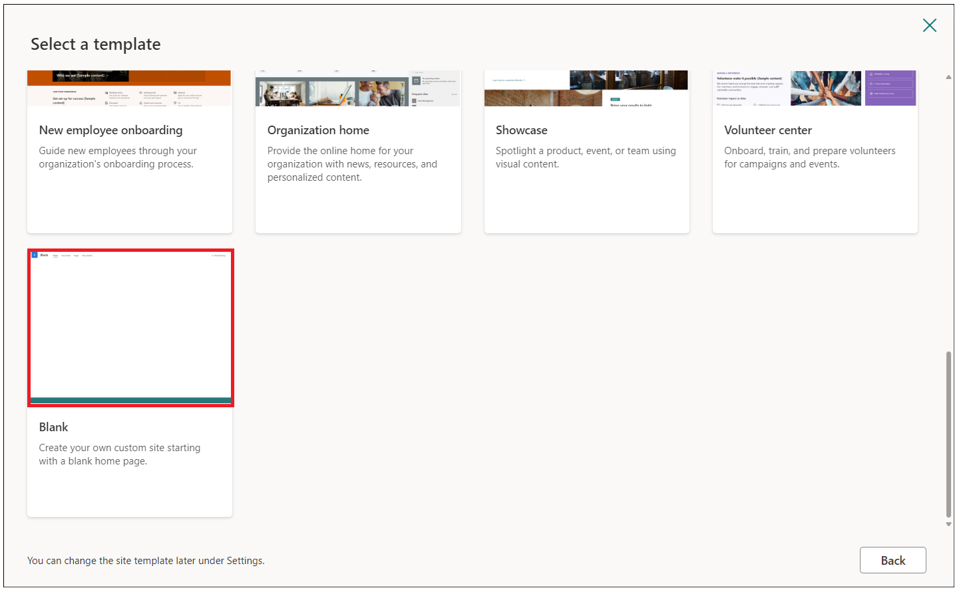

1. Click on **Use template**.

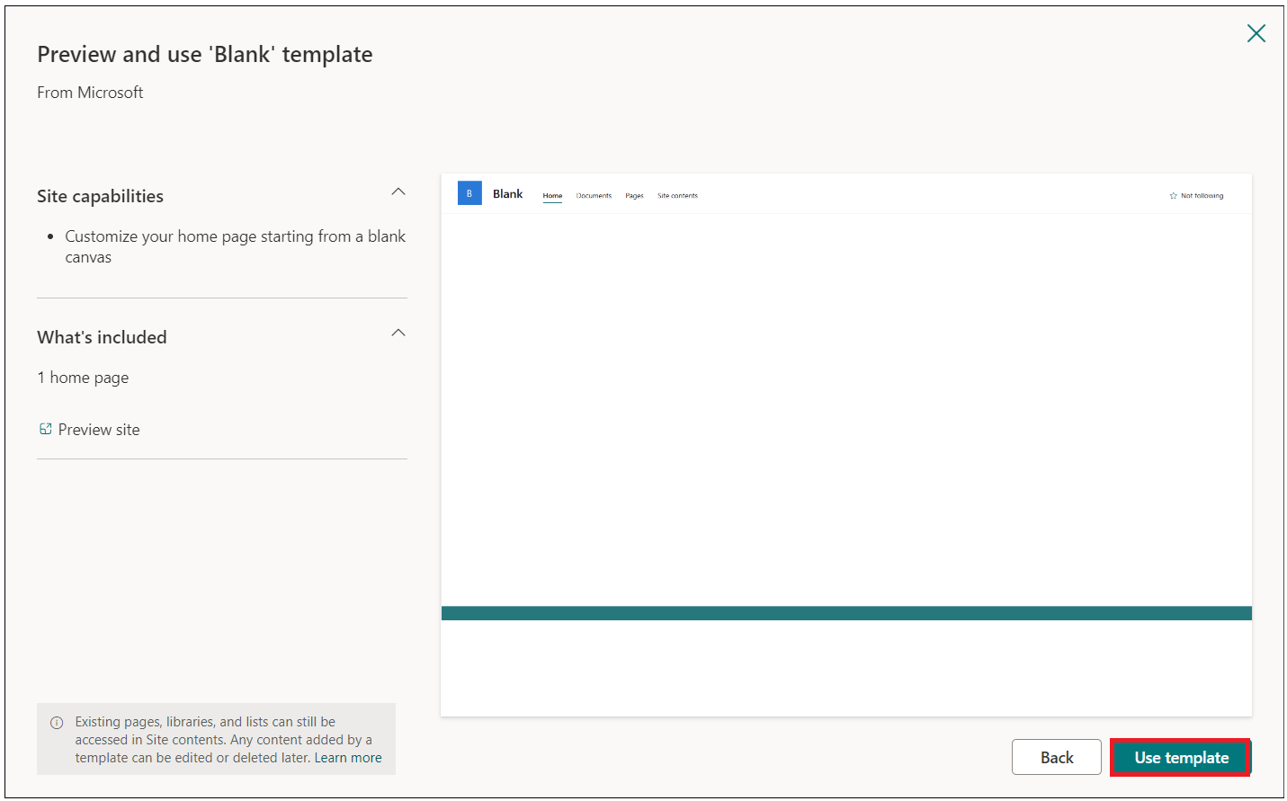

1. Enter Site name and description then click on **Next** button.

* Site Name: **Contoso Corp**
* Site Description: **Onboarding new employee.**

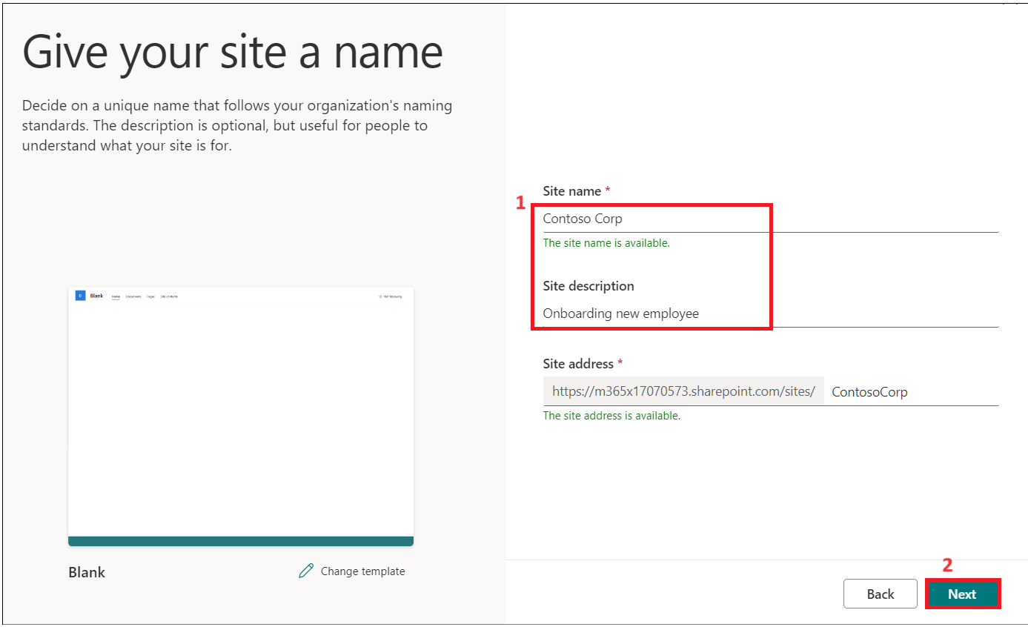

1. Keep the default language and then click on **Create Site.**

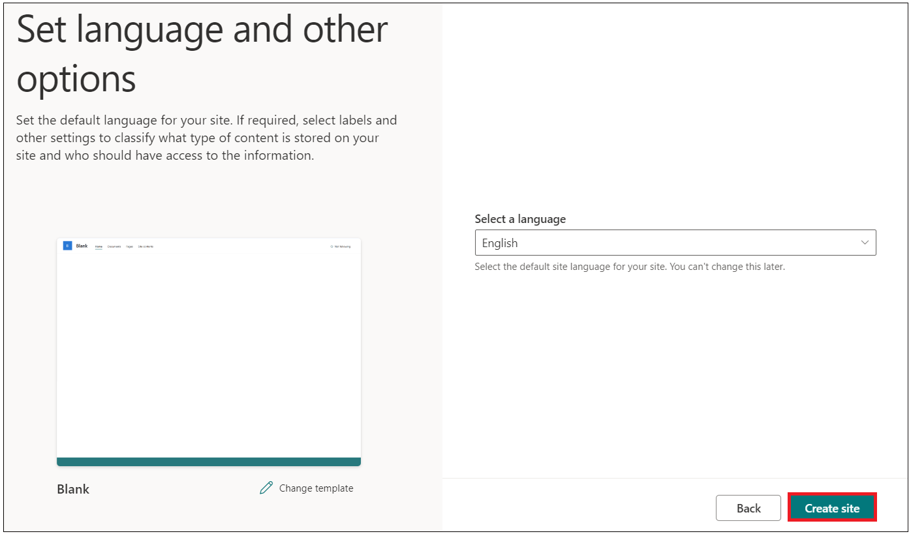

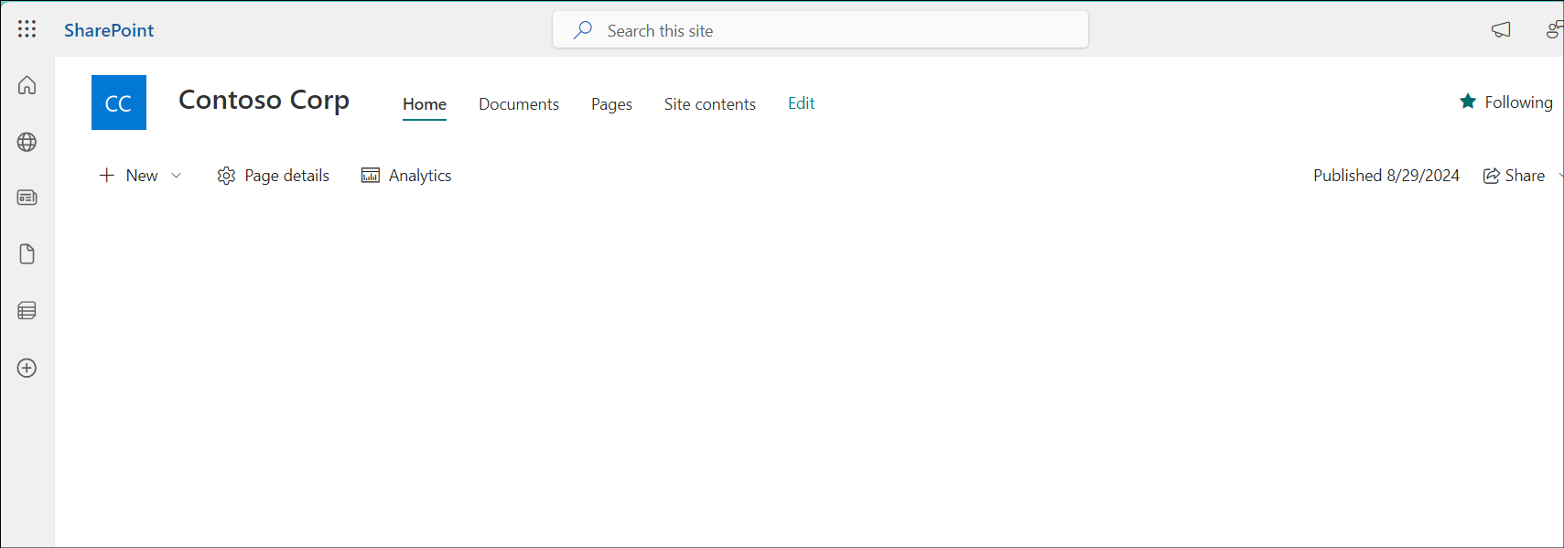

## Task 3: Create an Employees list in SharePoint site from CSV file

1. Click on **Home- >New -> List.**

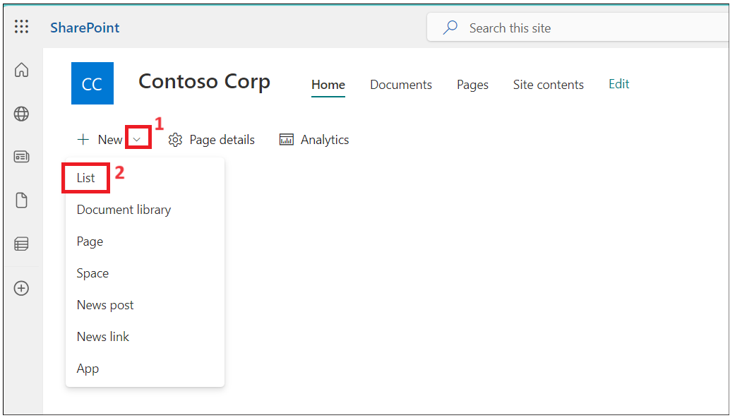

1. Select **From CSV** tilefrom **Create a list** window**.**

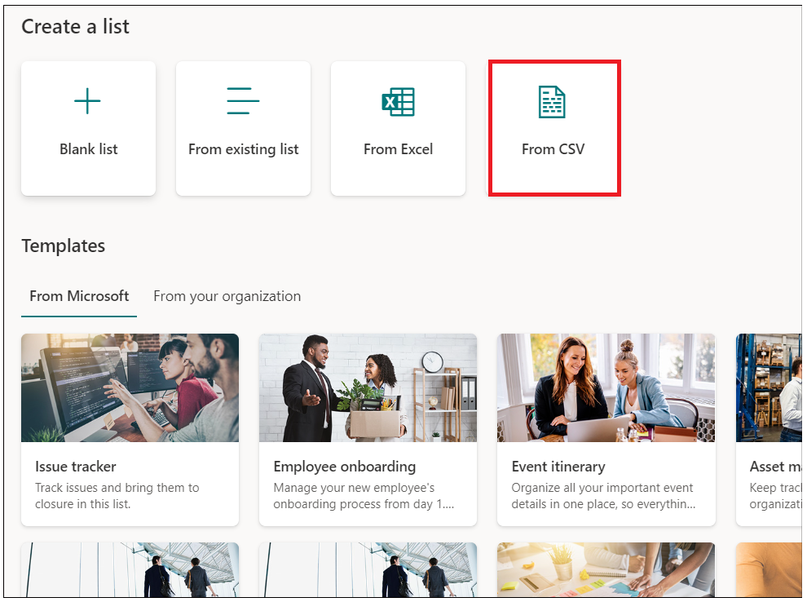

1. Click on **Upload file** and browse to **C:\Labfiles** and select **Employee.csv** file.

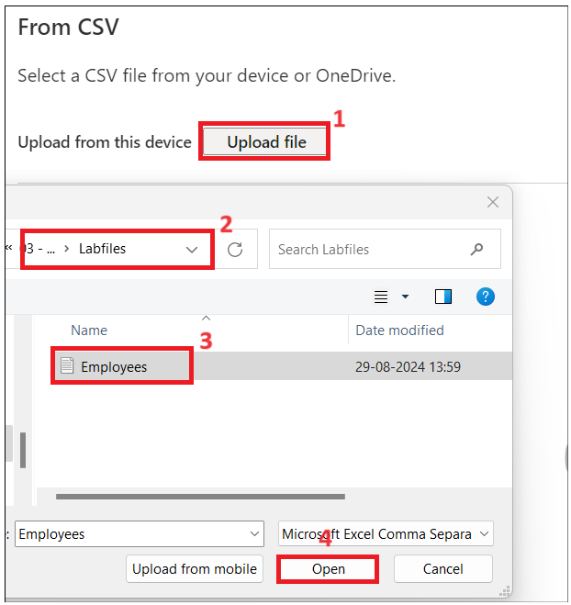

1. Change **Work Email** column type to **single line of text** and then click on **Next**.

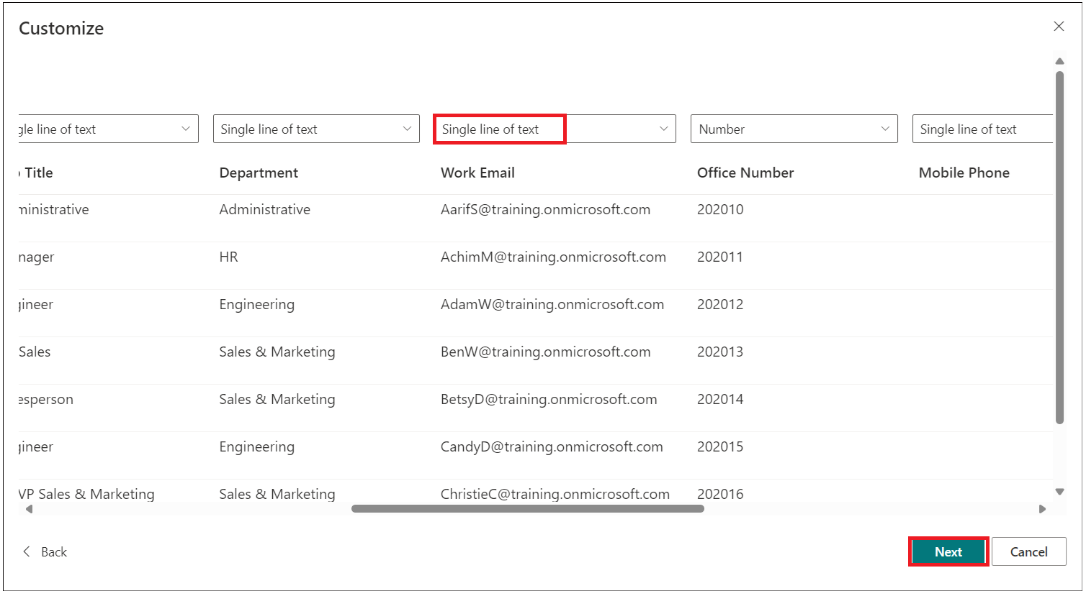

1. Enter then Name as: **Employee Onboarding** and Description: **New Contoso Corp employee** and then click on **Create**.

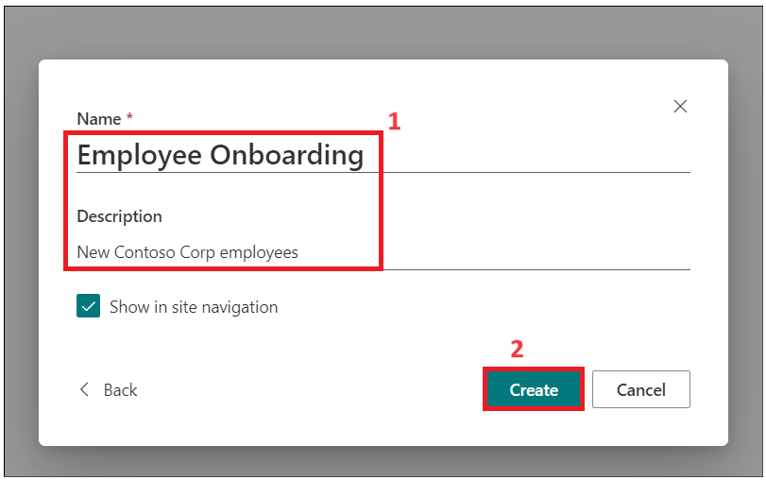

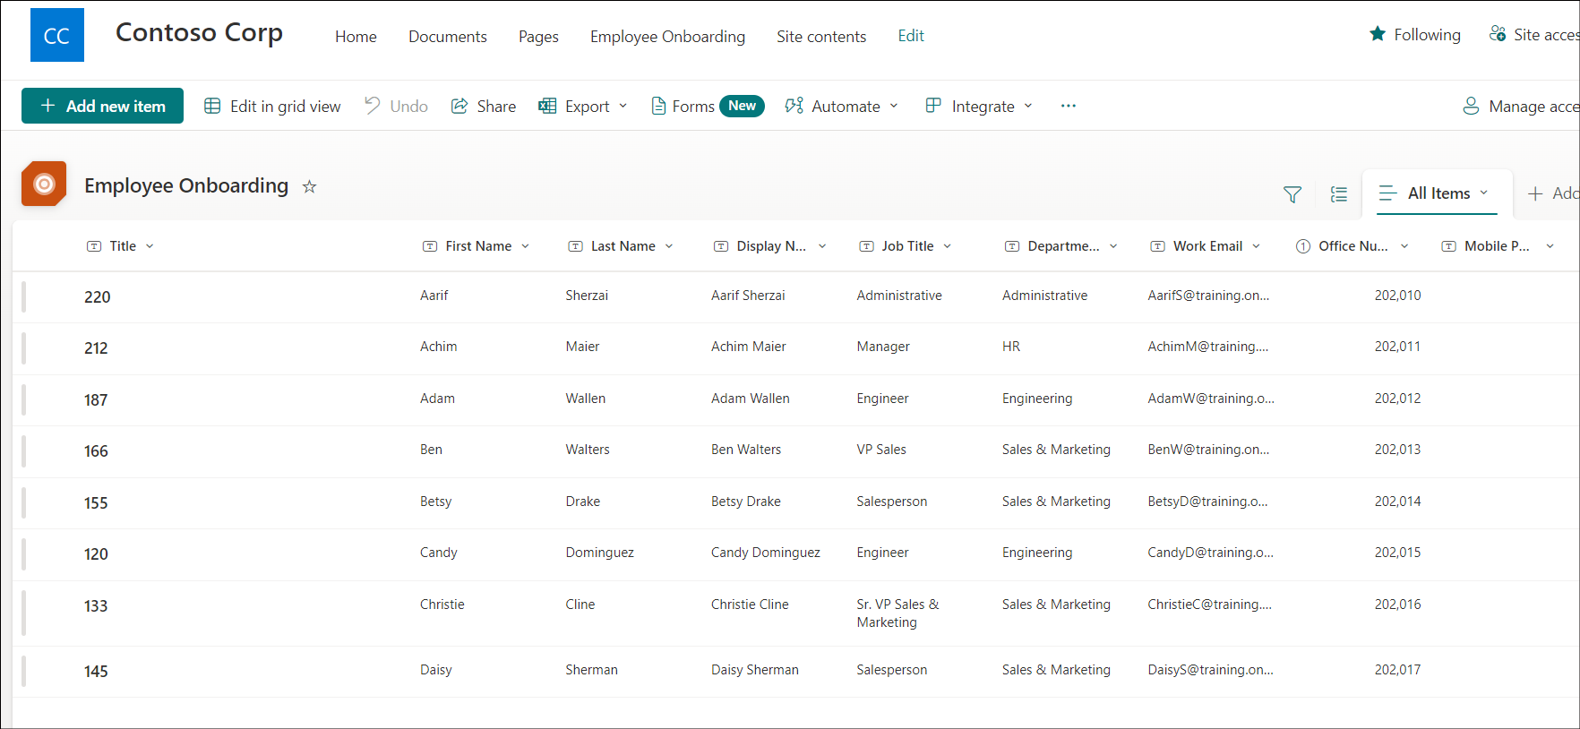

1. The Employees list is created for you now. Rename the **Title** column to **Emp_id**.

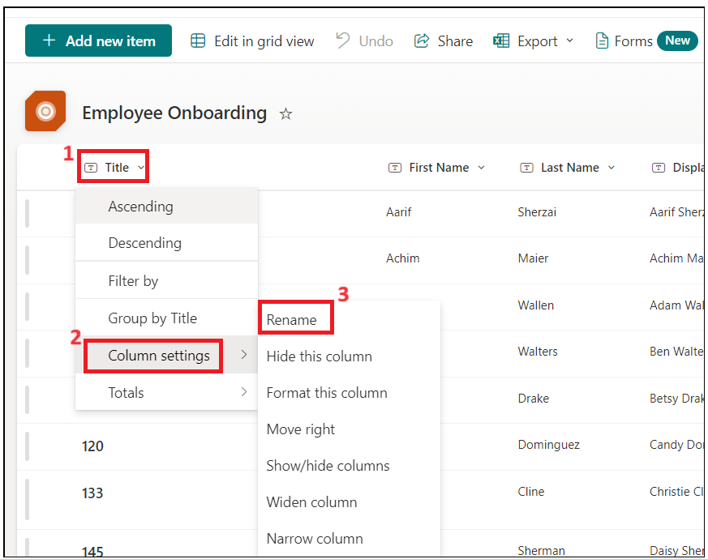

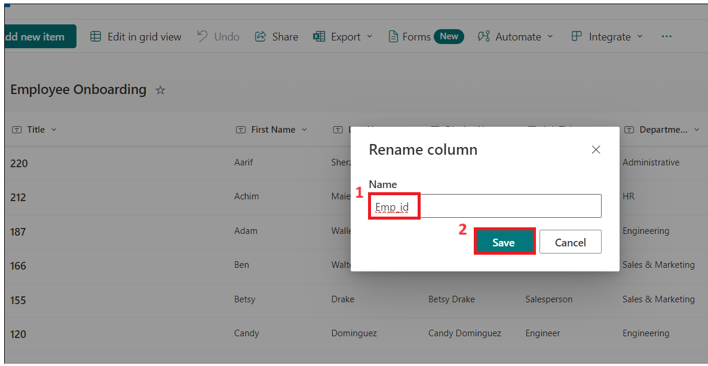

1. Now the employee table should like this

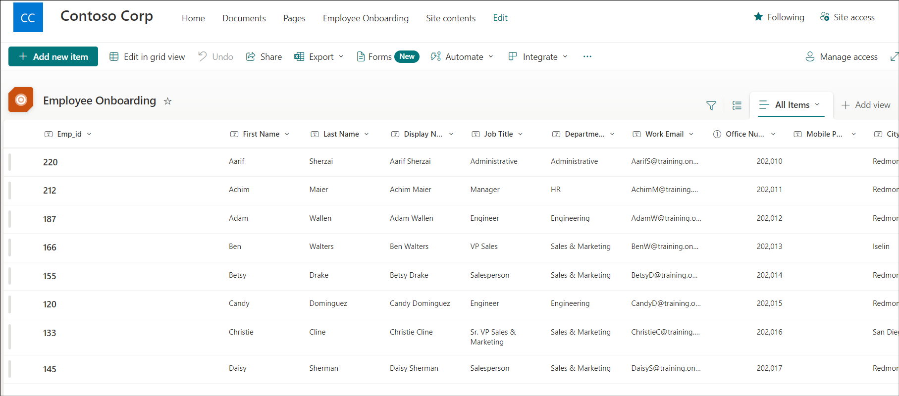

1. Click on **Settings ->List settings.**

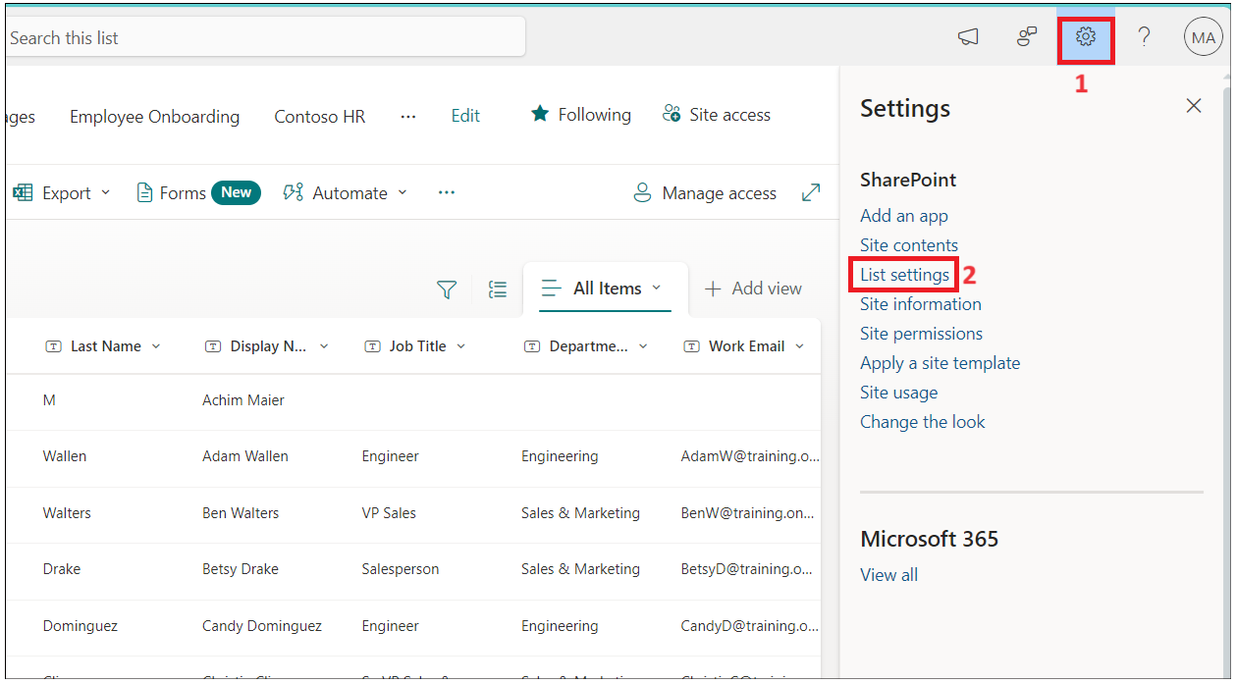

1. Click on **Department** column link.

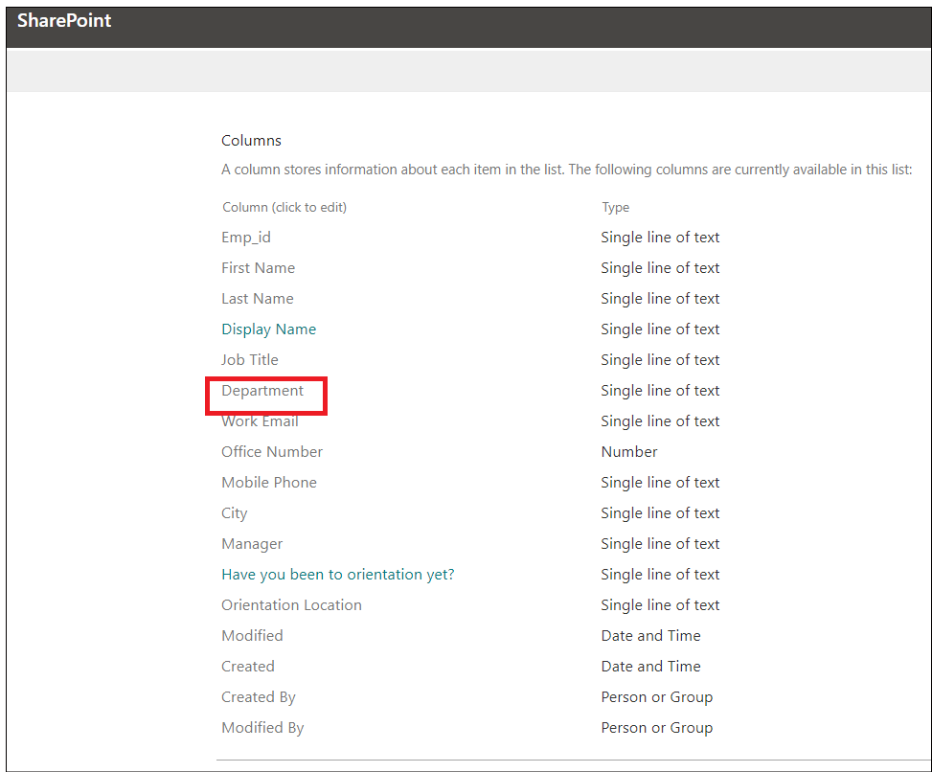

1. Change below values and then click on **Ok**.
   * Type of Column : **Choice**
   * Allow 'Fill-in' choices: **Yes**

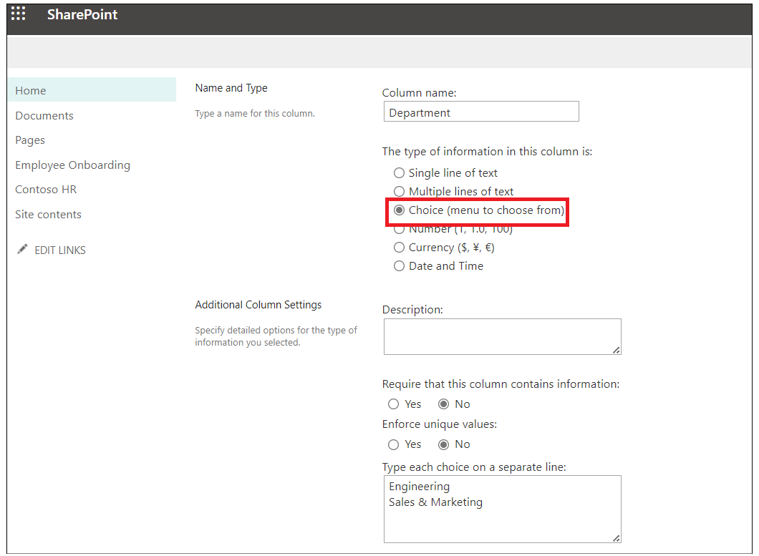

1. Repeat the above step for **Job title** column also
2. Select **Have you been to orientation yet?** column and make below chagnes and then click **OK**.
   * Type of Column : **Choice**
   * Allow 'Fill-in' choices: **Yes**
   * Type each choice on a separate line : **Yes No**

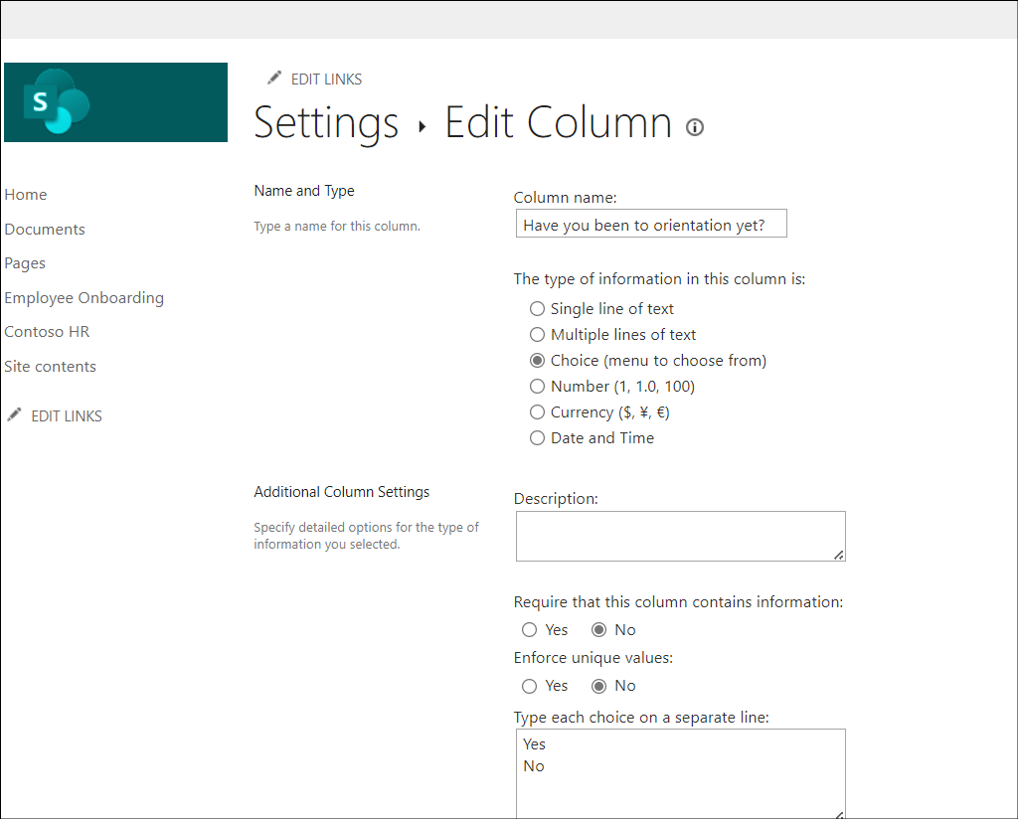

1. Repeat above step for **Orientation Location** with below properties
   * Type of Column : **Choice**
   * Allow 'Fill-in' choices: **Yes**
   * Type each choice on a separate line : **Redmon Reno**

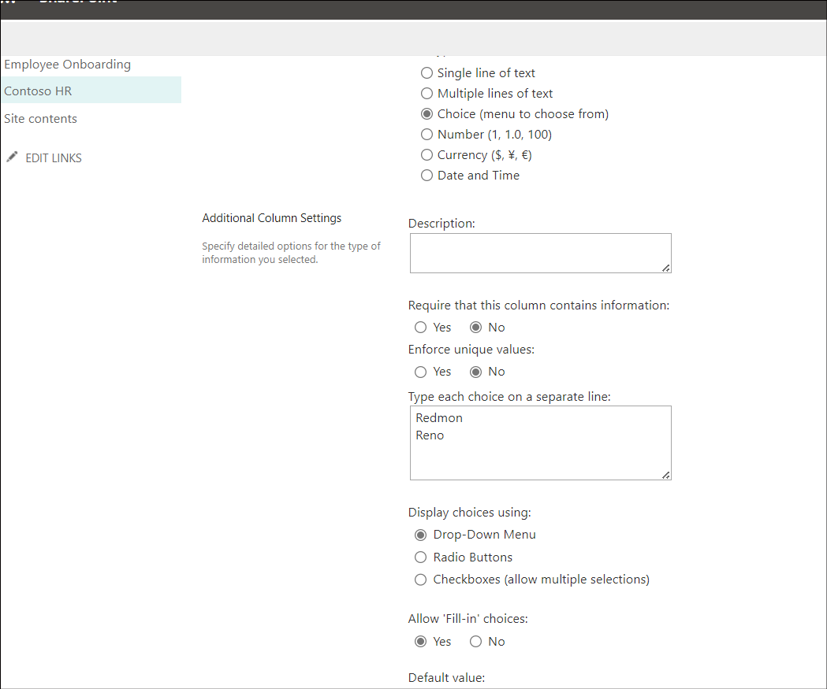

1. Repeat above step for **Manager** column with below properties
   * Type of Column : **Choice**
   * Allow 'Fill-in' choices: **Yes**

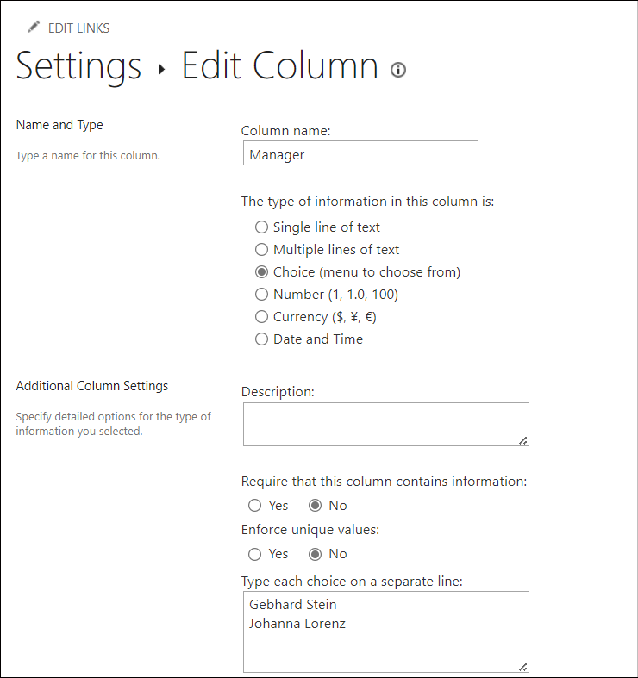

## Task 4: Create a HR list in SharePoint site from CSV file

1. Click on **Home- >New -> List.**

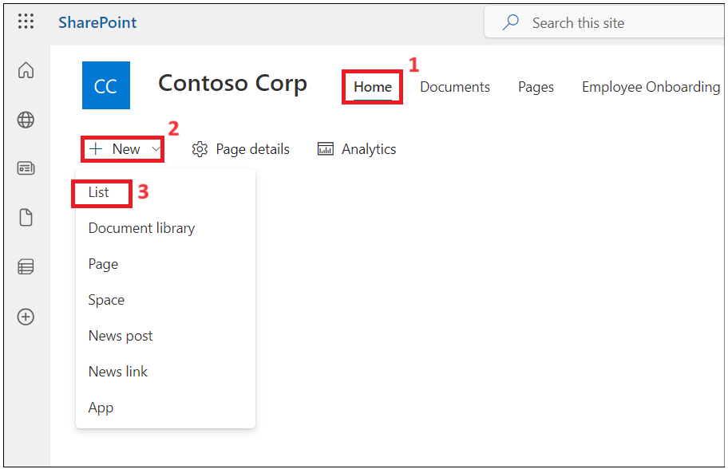

1. Select **From CSV tile** from **Create a list window.**

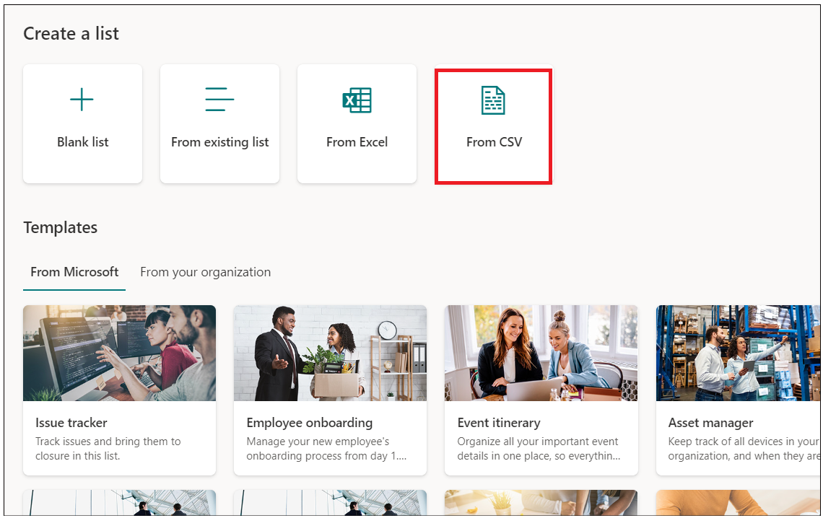

1. Click on Upload **file** and browse **C:\Labfiles** and select **Import_HR_M365.CSV** and click **Open**.

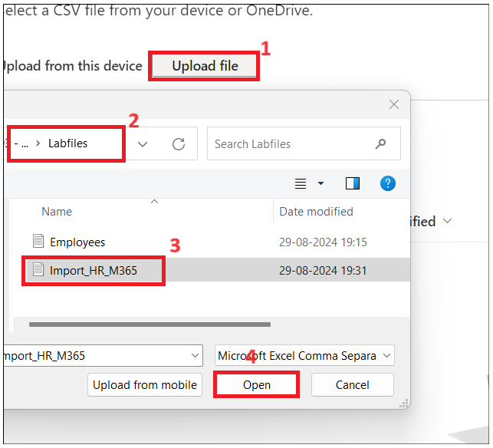

1. Change **Work Email** column type to **Single line of text** and then click on **Next**.

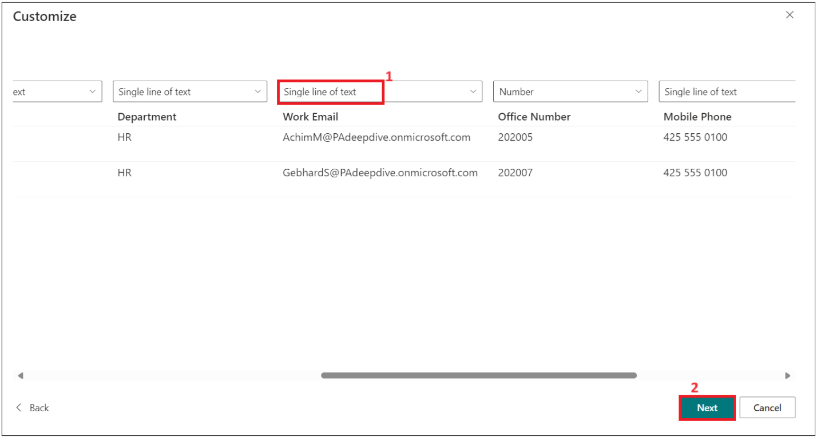

1. Enter below details

* Name : **Contoso HR**
* Description : **Contoso Human Resource**, then click on **Create** button.

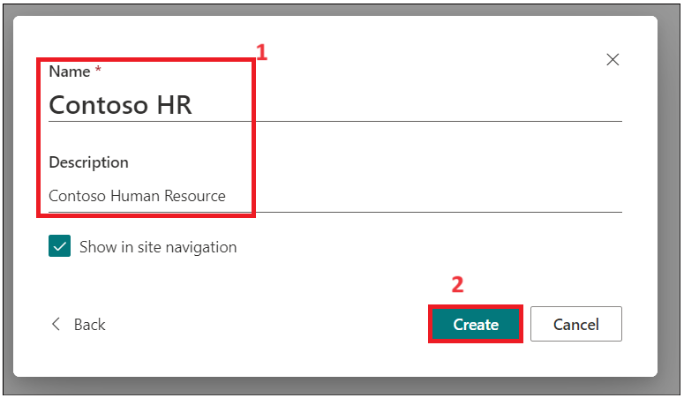

1. Click on **Title -> Column settings -> Rename**  columnt to **Emp_id**.

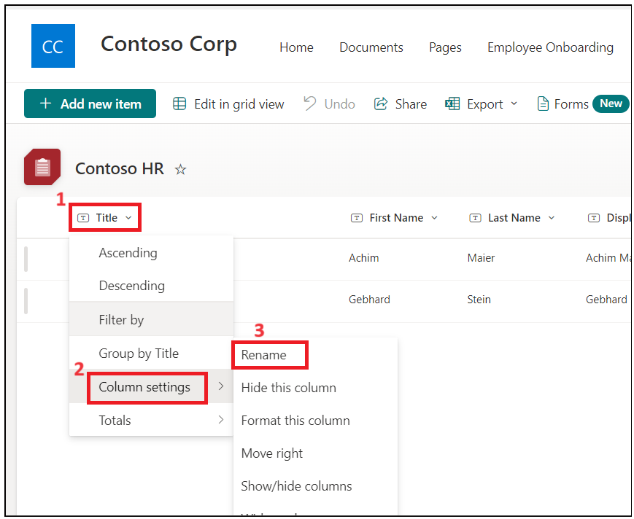

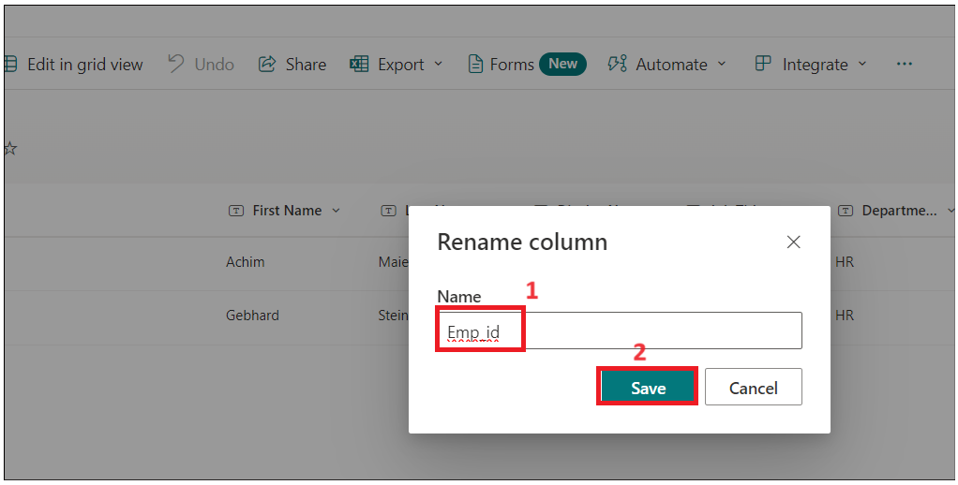

1. The HR table should like below image now.

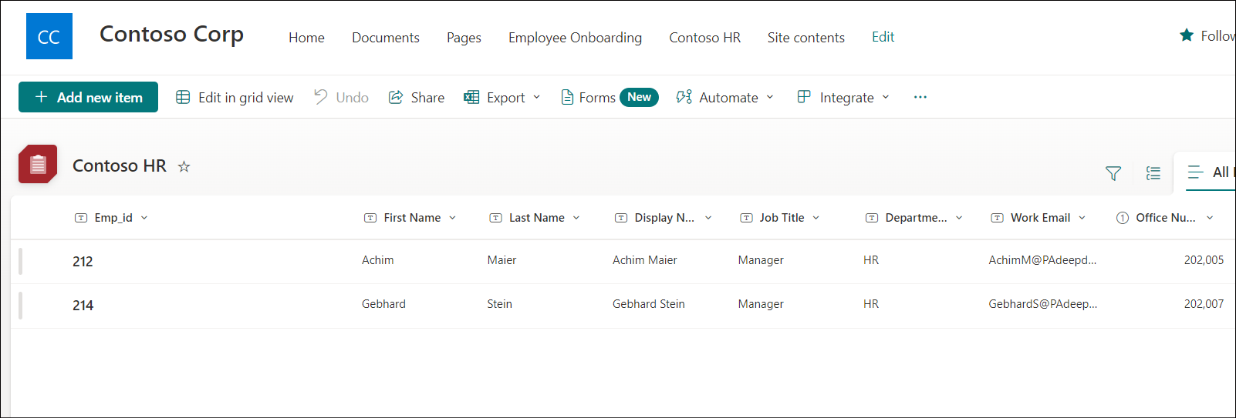

## Conclusion

After completing this exercise, you will have:

1. **Lists in SharePoint with Employee information**

These are SharePoint lists used to store and manage details about employees. They include fields for various employee data such as names, contact information, roles, departments, and other relevant attributes.

# Exercise 2: Create Power Apps for SharePoint Lists

In this exercise, you will build your application to send an email to employee with official information and asking him to fill and upload documents.

## Task 1: Customize Employee form with PowerApps for HRs to fill.

1. From your **SharePoint-> Employee onboarding**, copy URL and save it in Notepad.

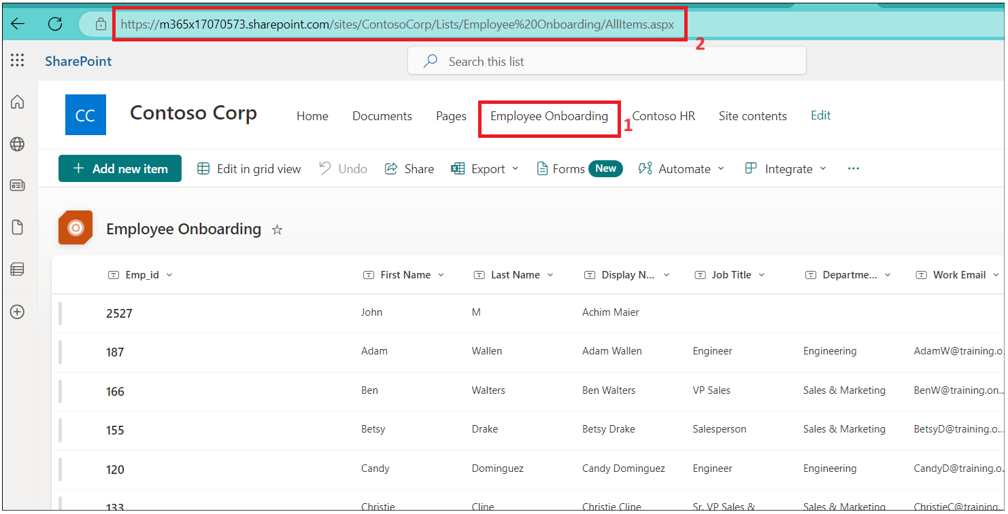

1. Open a new tab and go to[**https://make.powerapps.com/**](https://make.powerapps.com/)**.** Sign in with your office 365 admin tenant and select your **Dev One** (Developer) environment.

**Note**: For your tenant, the name of the environment can be different. Make sure that the environment that you have selected is a **developer** environment)

1. Click on **Apps** from left navigation menu. Select **New App- > Start with a page design.**

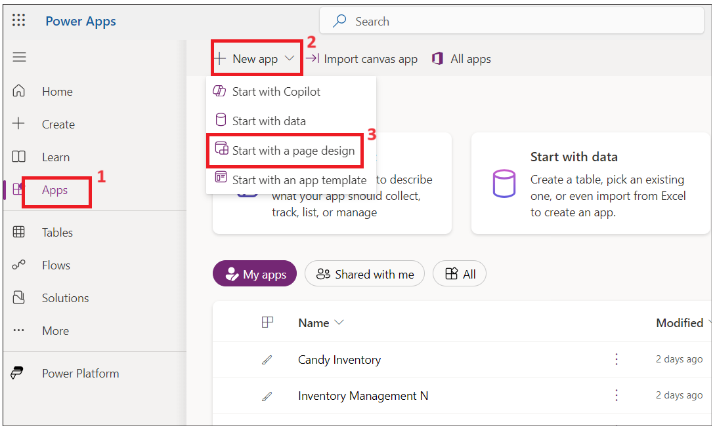

1. Select **Blank Canvas** tile**.**

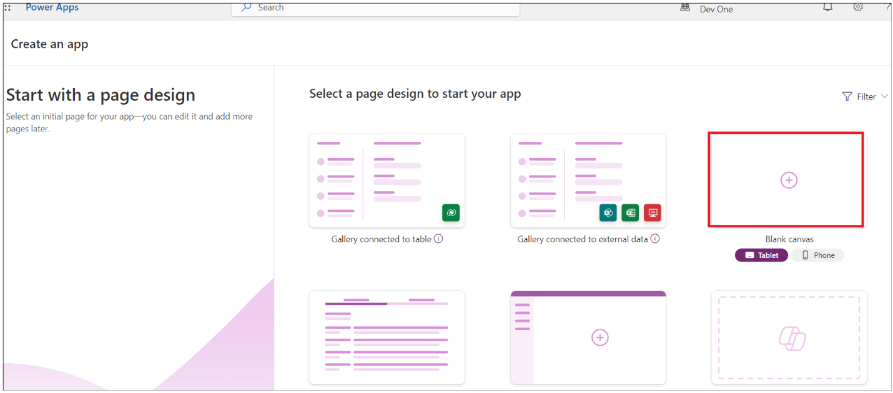

1. Right click on Screen1 and select **Rename.**

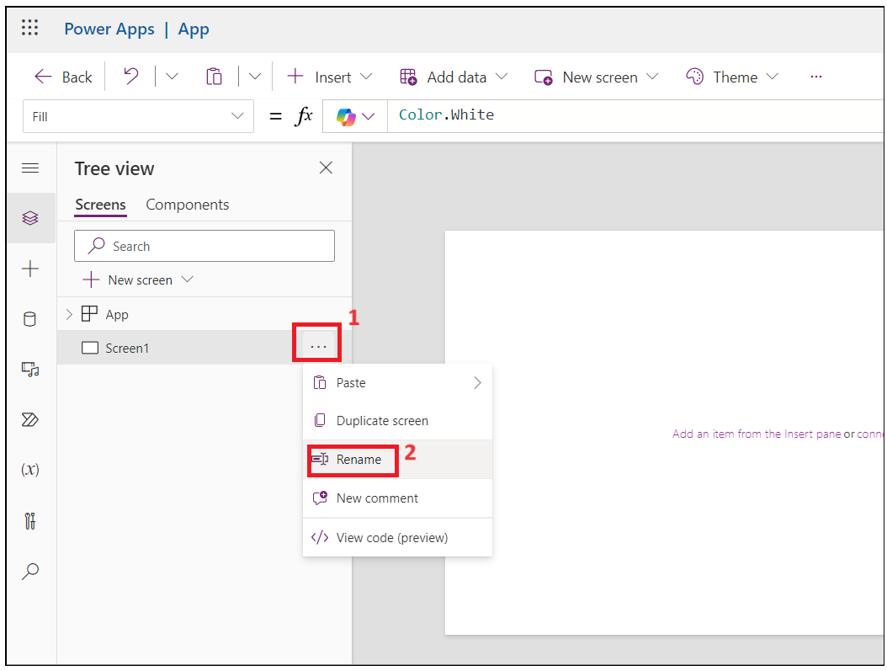

1. Rename to **HrEmployeeform**

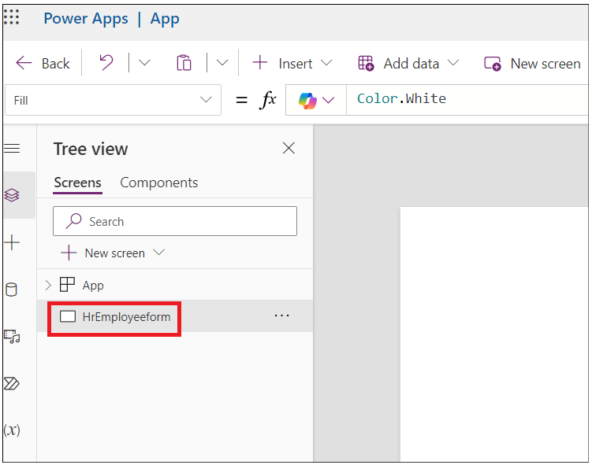

1. Select the form andclick on **Insert-> Edit form.**

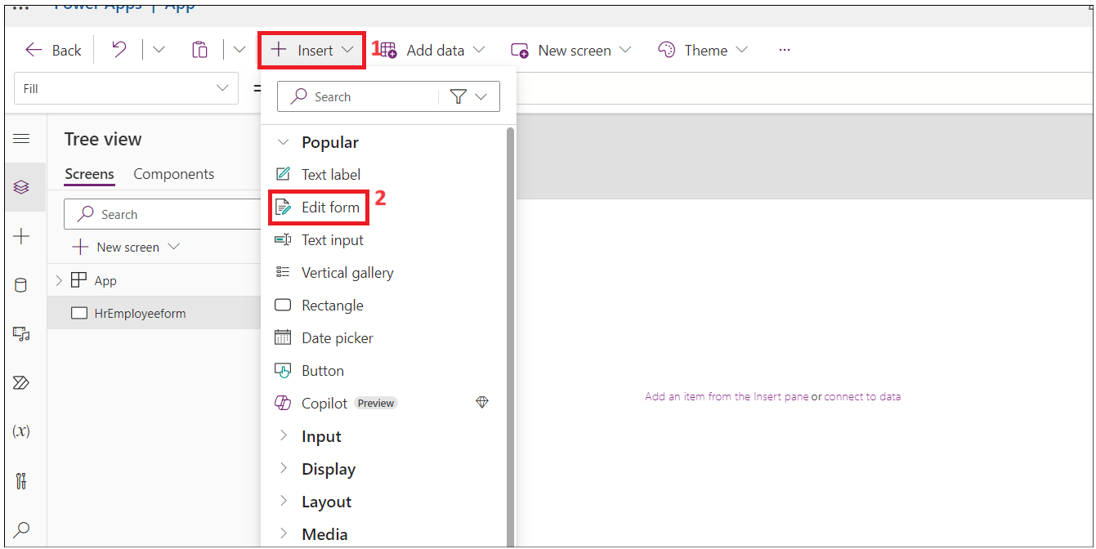

1. Search for **SharePoint** and select **SharePoint connector** from **Select a data source** dropdown**.**

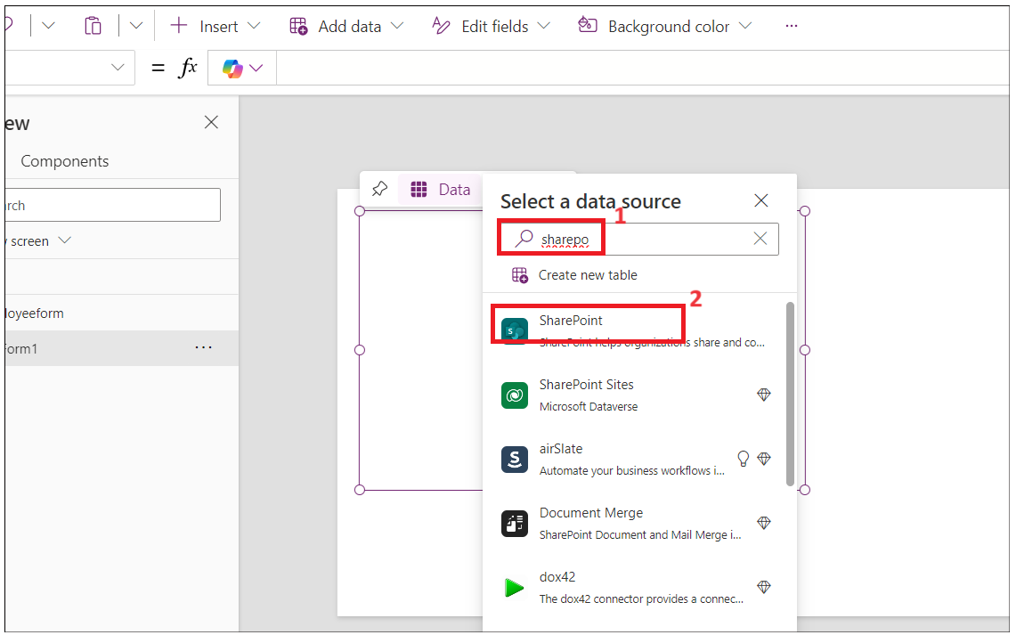

1. Select **SharePoint** under **Connect.**

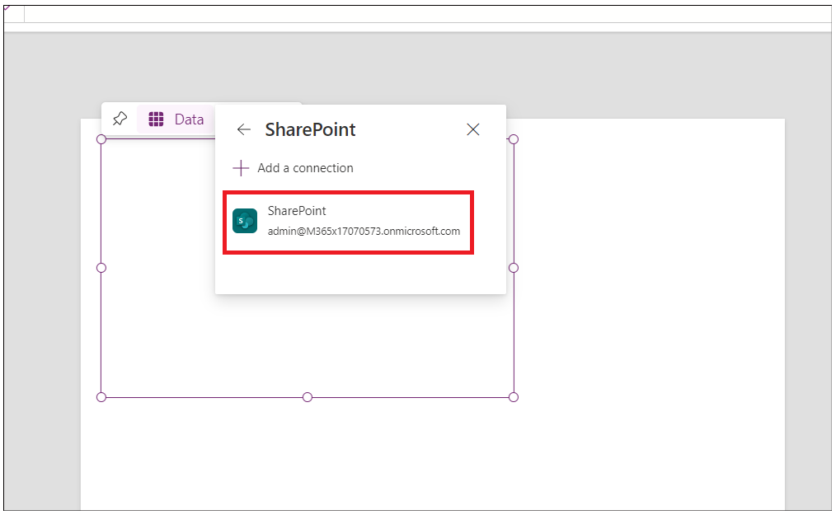

1. Enter the **SharePoint list URL** copied form step 1 into **Enter SharePoint URL** text field and then click on **Connect**.

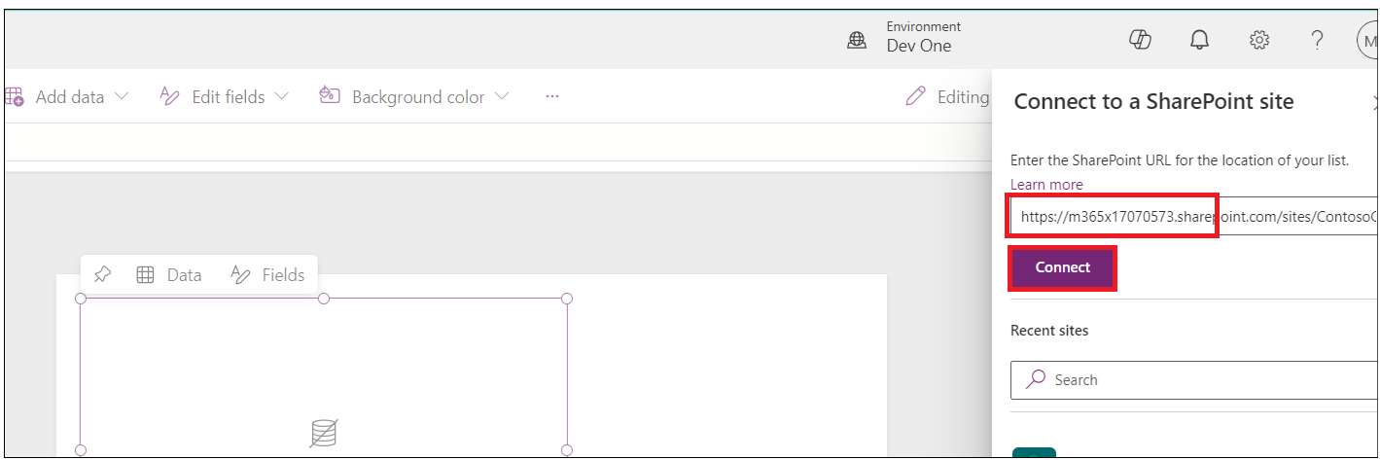

1. Select **Employee Onboarding** list and then click on **Connect**.

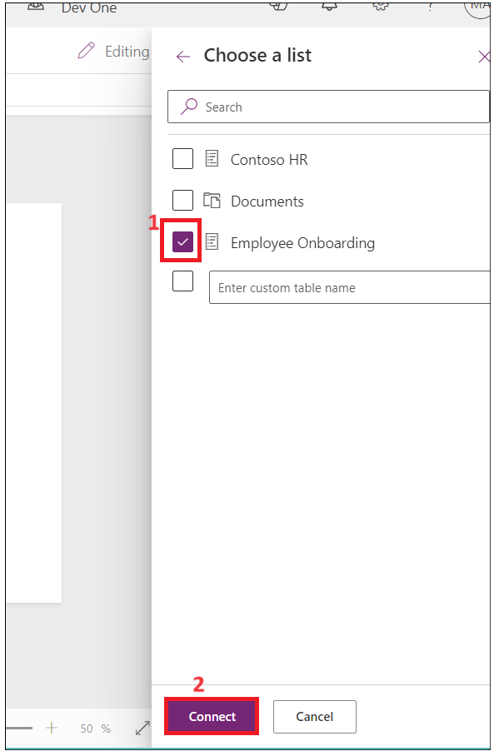

1. Drag and fit the form into the container.

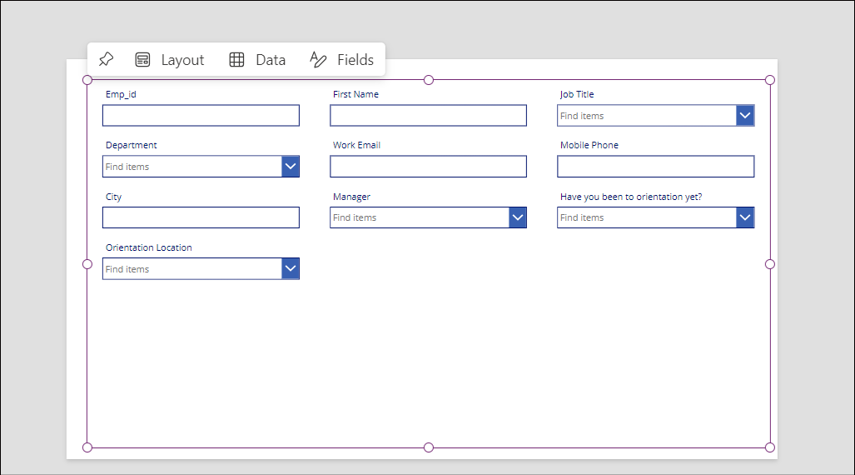

1. Drag the Form1 container little down and click on **Insert- > Rectangle** to insert header to the form.

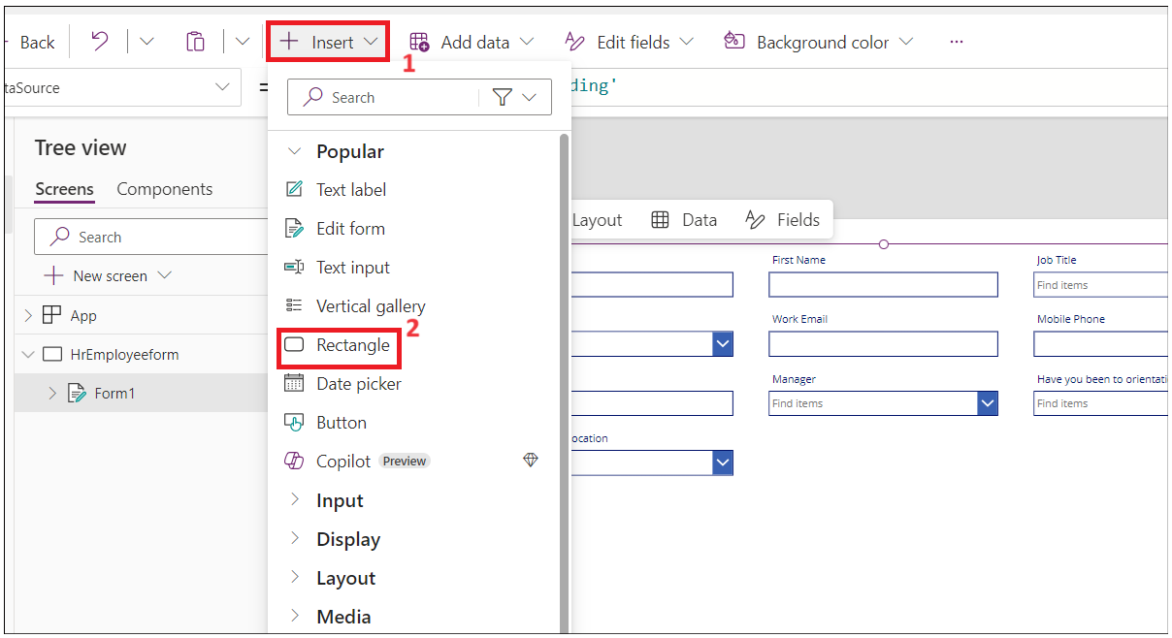

1. Adjust the rectangle to the container width. Click on **Insert- > Text label**.

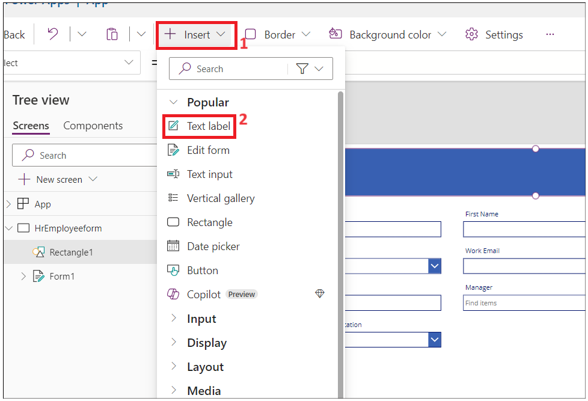

1. Change the width of the text field to the rectangle and update below properties.

* **Tex: New Employee Onboarding Form**
* **Font Size:** 27
* **Font weight:** Bold
* **Text alignment:** Centre
* **Colour:** White

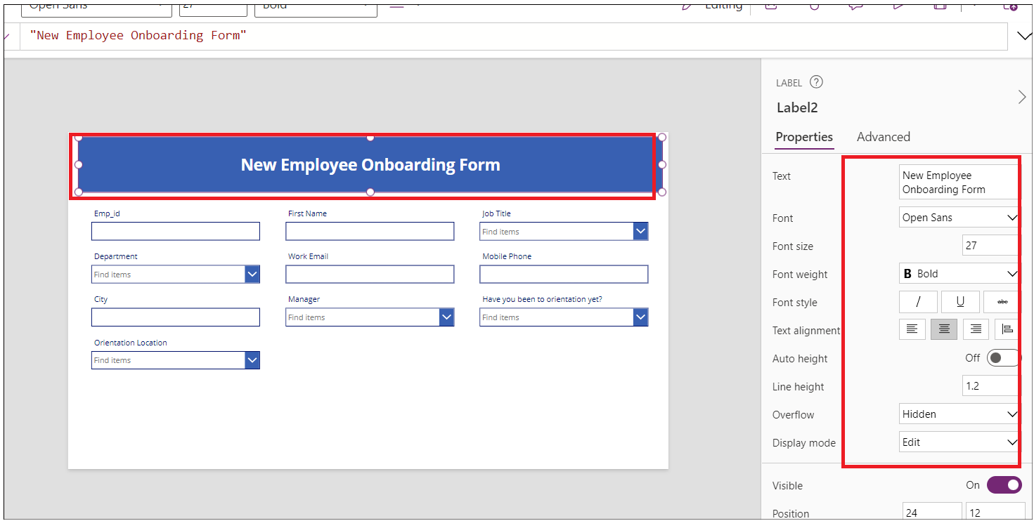

1. Make **Emp_Id, First Name** and **Last_Name** as required fields.
2. Select **Emp_Id** field and change value **required**. Click on **Advanced** under **Properties** and select **Unlock to change properties**.

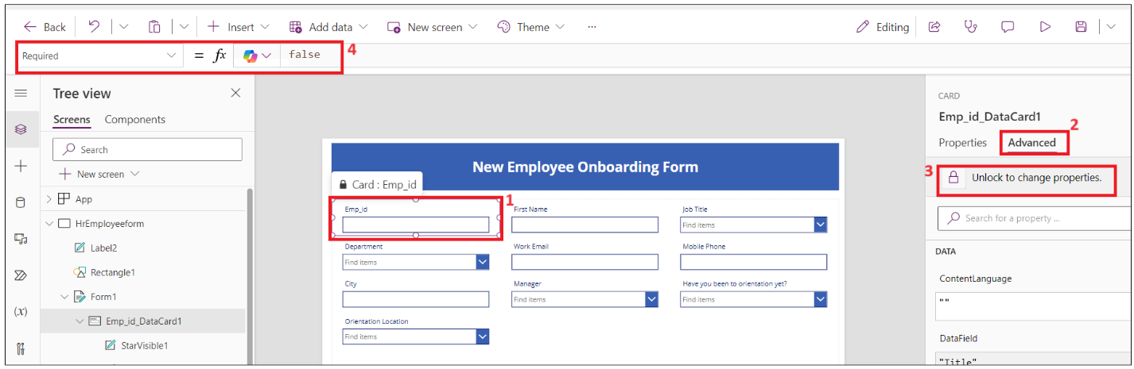

1. Now set the **Required** value to true. You should see star next **Emp_id** field.

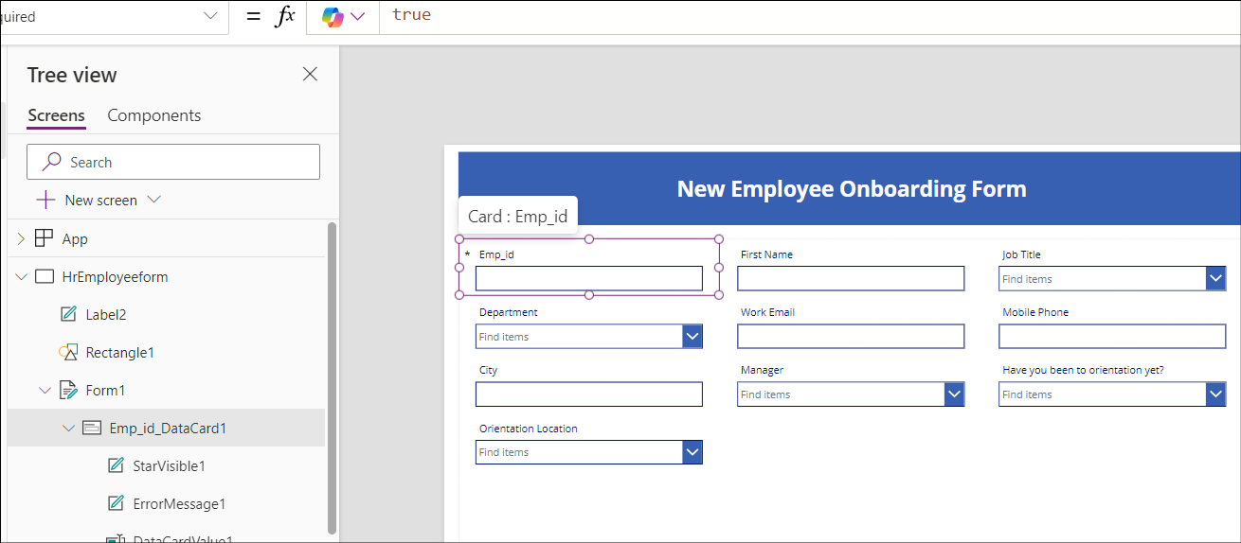

1. Repeat above two steps for **First Name** and **Last_Name**

Note: If you don’t see field then select the container- > properties-> Edit( fields) .add field and re-order.

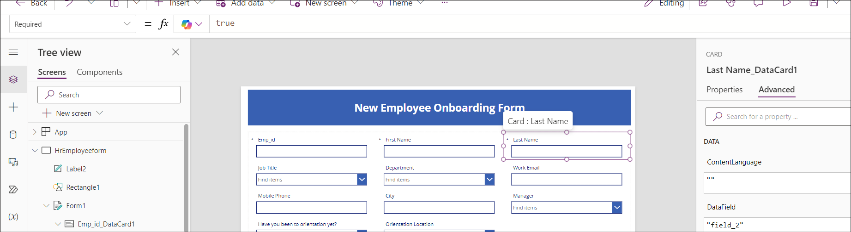

1. Select the Rectangular form/FormScreen1 and then click on **Insert -> Button**.

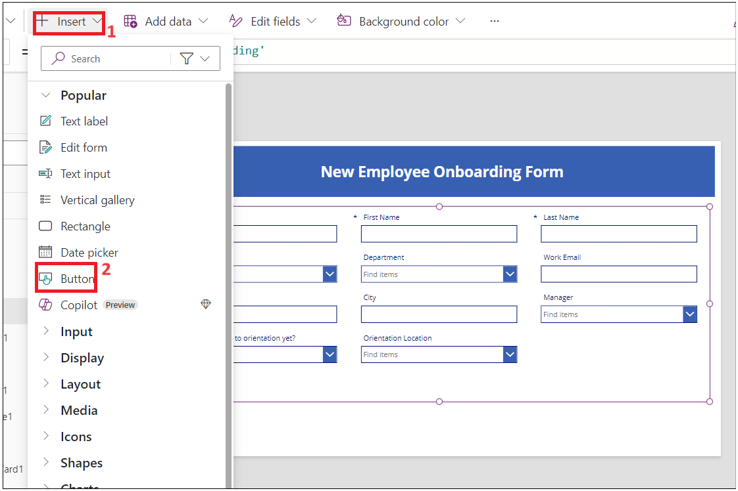

1. Drag and place the button under **Department** filed in the form and update below properties.

* **Text: Submit**

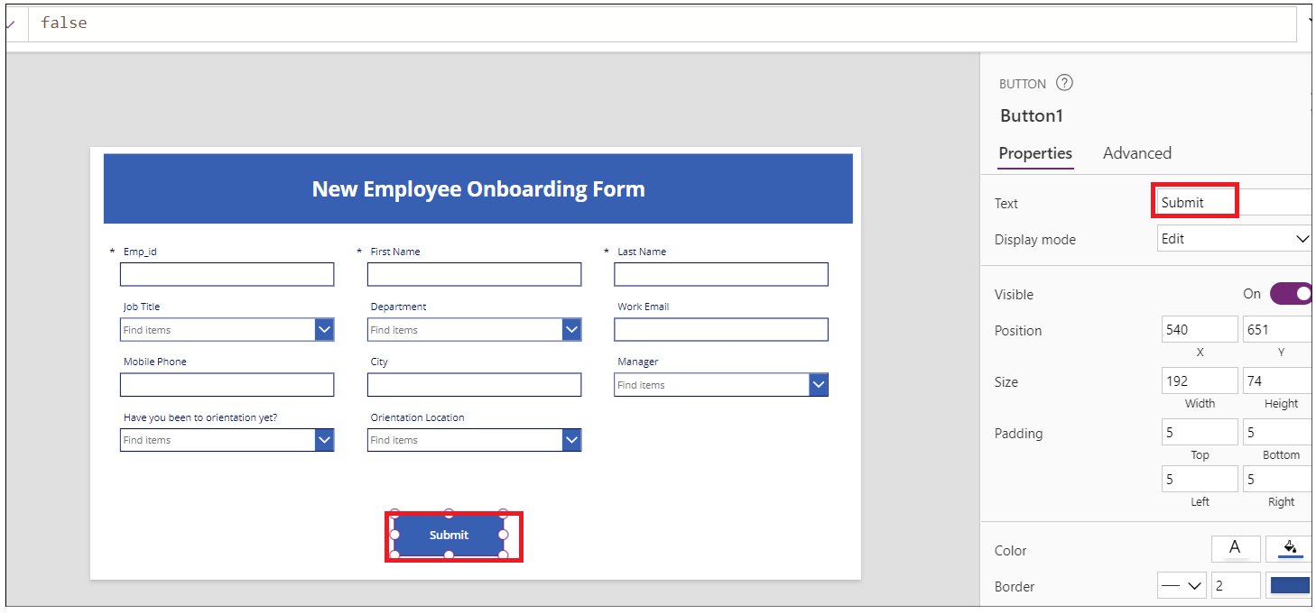

1. Click on **New Screen** and select **Success** template**.**

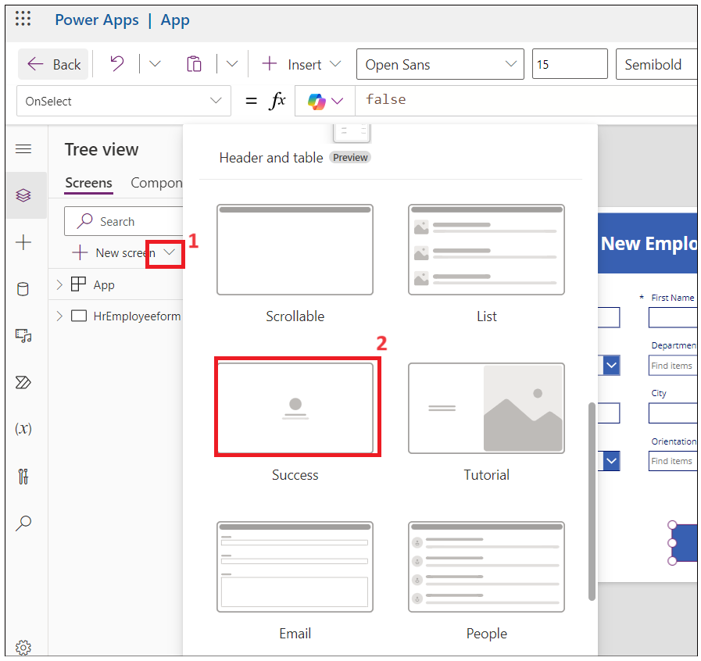

1. Select the new screen and **rename** to **Success** as shown in below images.

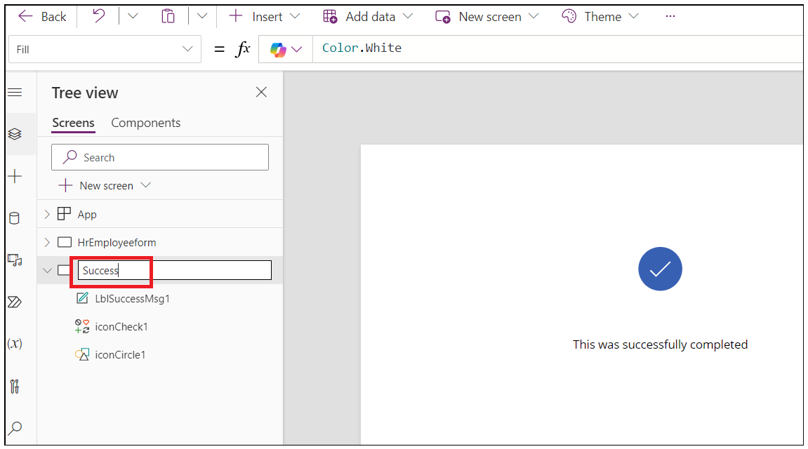

1. Select **Lb1Successmsg1** and change the text to **New employee added**.

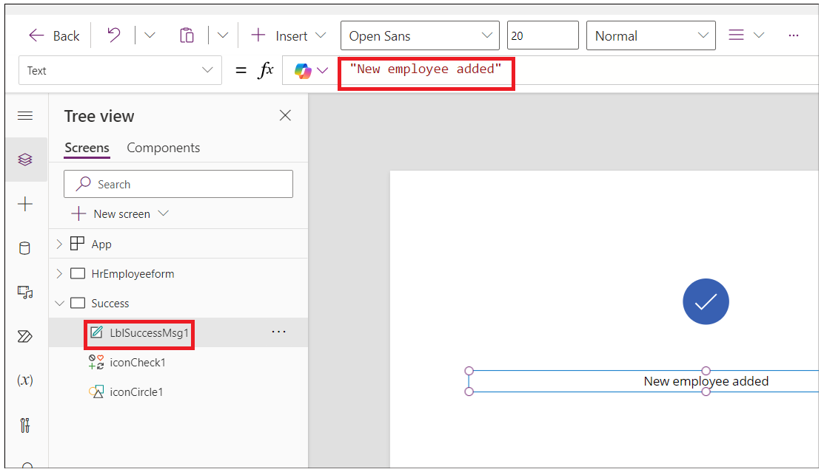

1. Now, Click on **Insert -> Icons-> Back arrow.**

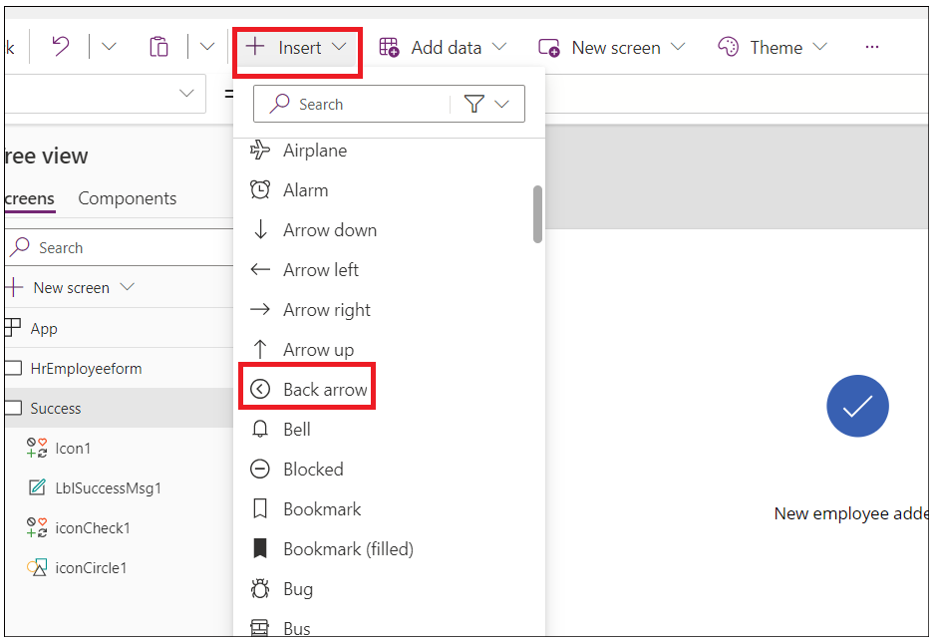

1. Select Back Arrow and set below properties.

* Tool Tip**: Go Back**
* OnSelect**: Back(ScreenTransition.CoverRight)**

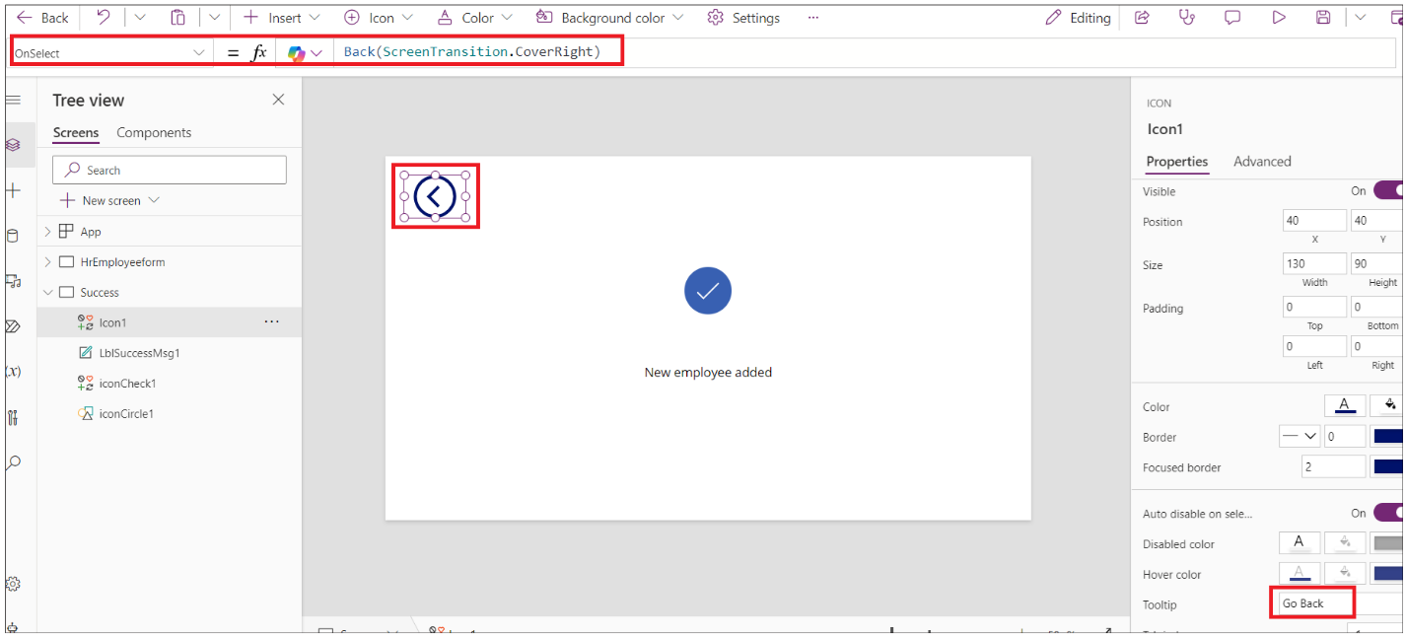

1. Click on **HrEmployeeform.** Select **Button** andselect **Onselect** and enter below formula.

**Note:** Update the formula with your SharePoint Form.

SubmitForm(*Form1*);ResetForm(*Form1*);Navigate(*Success*)

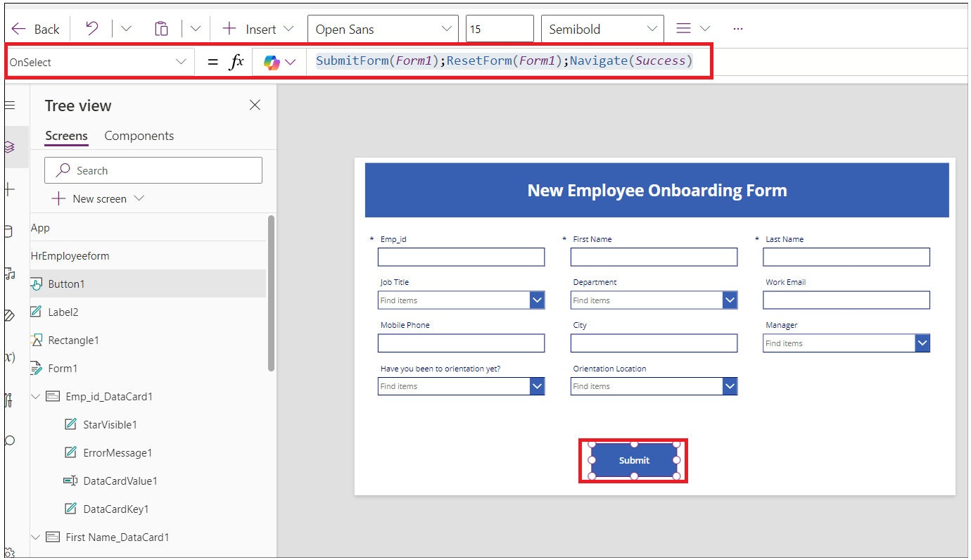

1. Select **Form1,** select **OnSuccess** and replace the formula with below formula.

ResetForm(Self); RequestHide();Notify("New Employee added",NotificationType.Success)

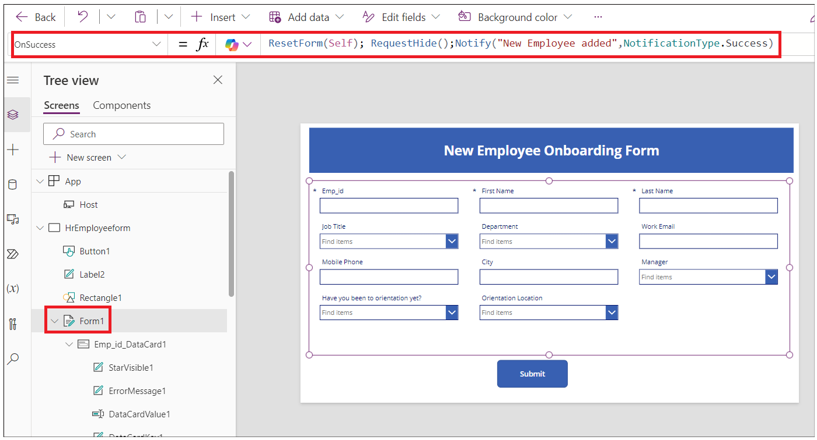

1. Click on **Save > Save as** button and enter the name as **EmpformforHr** and then click on **Save**.

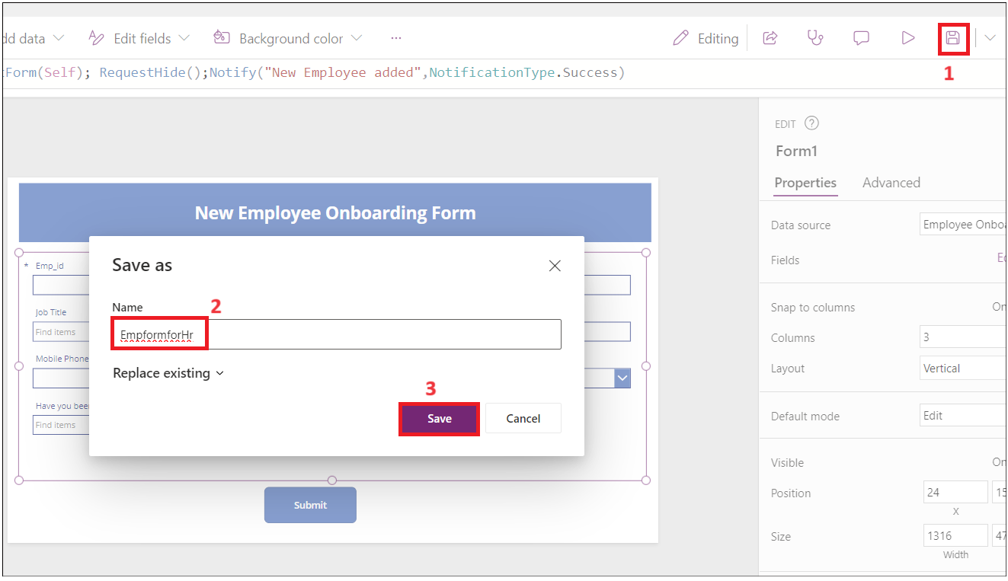

1. Select the form and change the **Default** mode to **New** and then click on the **Save ->** **Preview** icon.

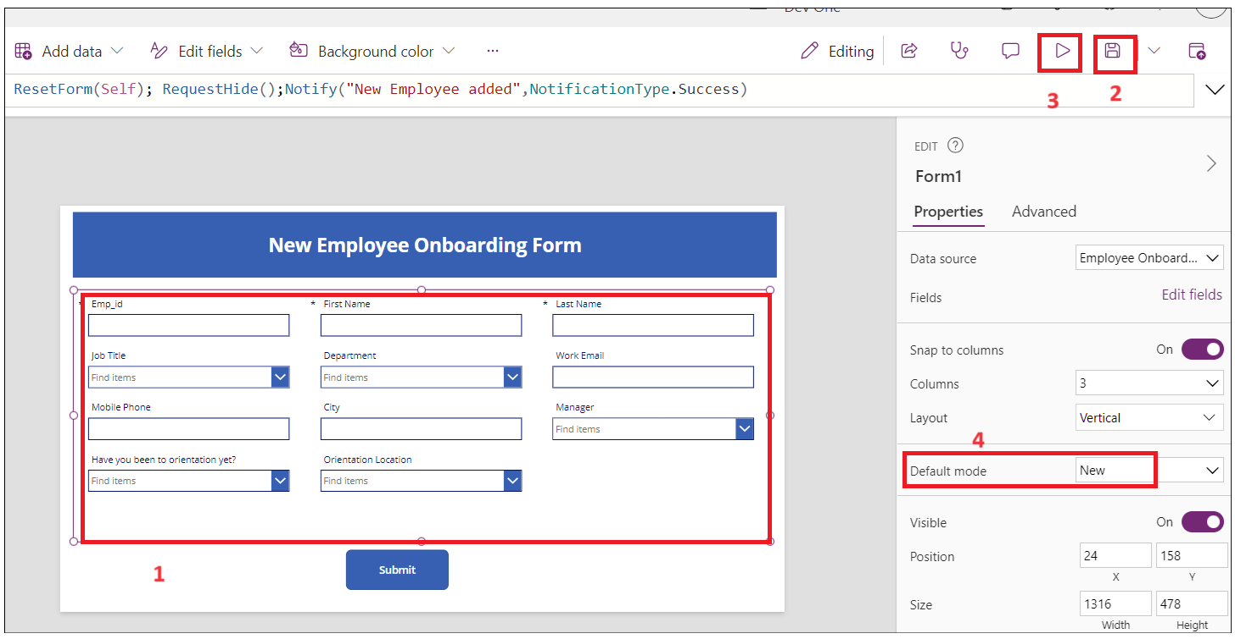

1. Enter random **Emp id, First Name** and **Last Name** and then click on **Submit** button**.**

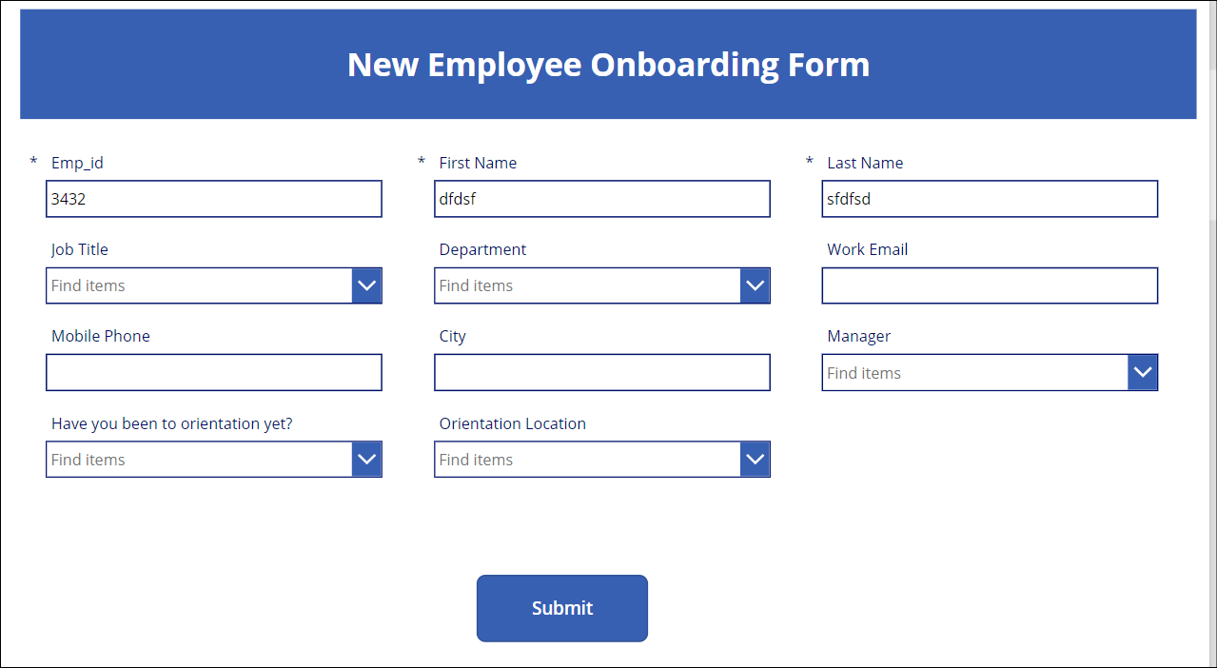

1. You should see **New employee added message.** Click on **Back** button**.**

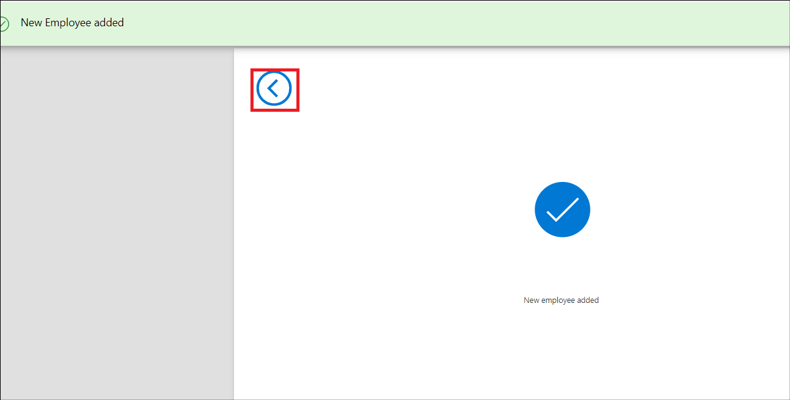

1. Click on **Publish** button and then click on **Publish this version** button.

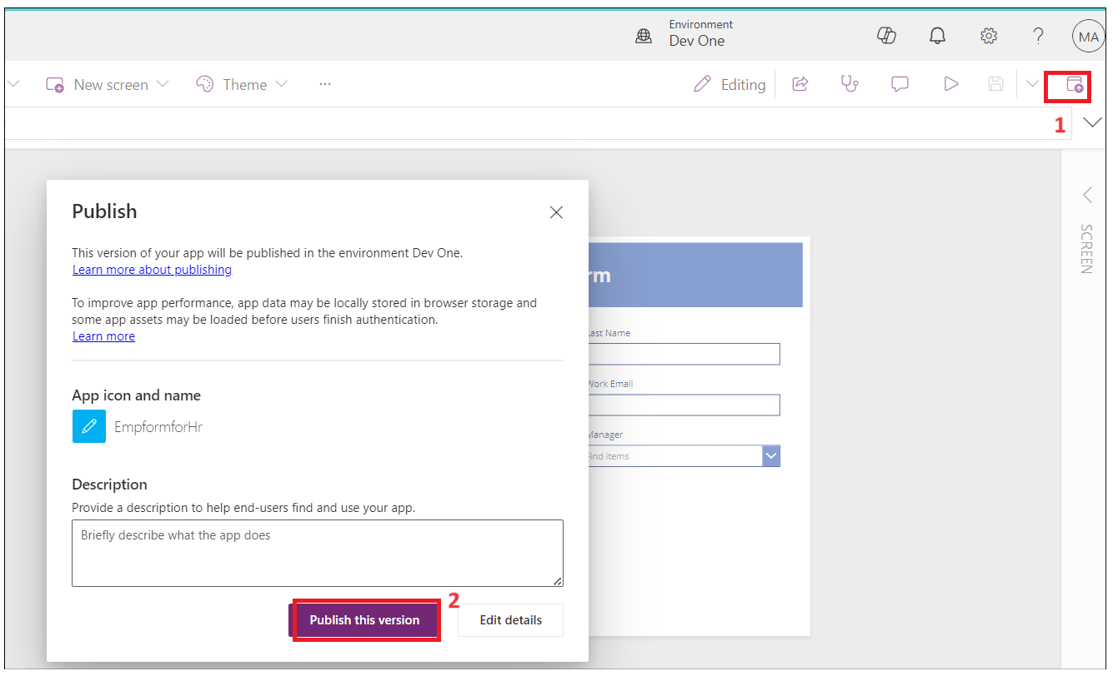

1. Go back to SharePoint tab in a browser. You should see the employee record of the new employee added by you in the list.

## Task 2: Create employee onboarding Canvas app for the employee

1. From your **SharePoint-> Employee onboarding**, copy URL and save it in the Notepad.



1. Open a new tab and go to[**https://make.powerapps.com/**](https://make.powerapps.com/)**.** Sign in with your office 365 admin tenant and select your **developer environment**.
2. Click on **Apps** from left navigation menu. Select **New App- > Start with a page design.**



1. Select **Blank Canvas** tile**.**



1. Right click on Screen1 and select **Rename.**



1. Rename to **Employeeform**

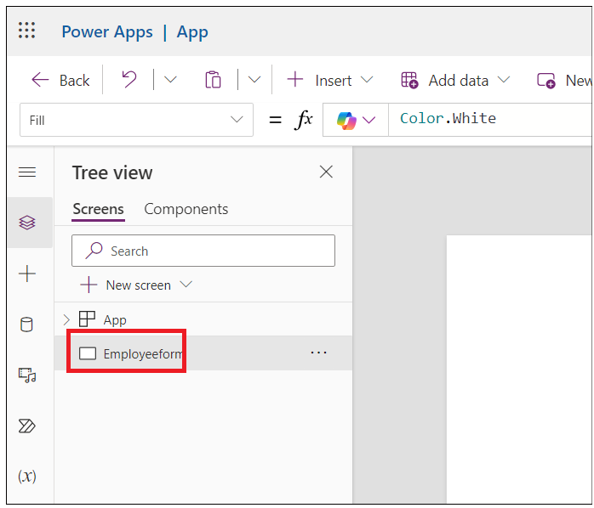

1. Click on **Insert** and select **Edit** form**.**

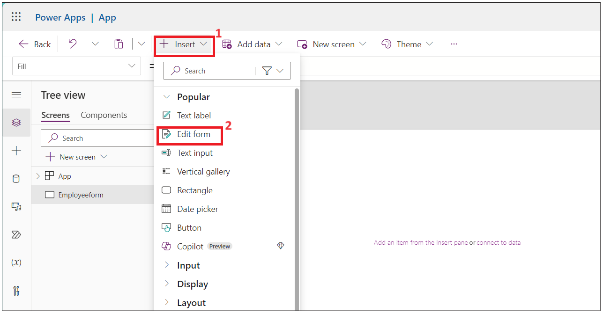

1. Search for **SharePoint** and select **SharePoint connector** from **Select a data source** dropdown**.**



1. Select **SharePoint** under **Add Connection.**

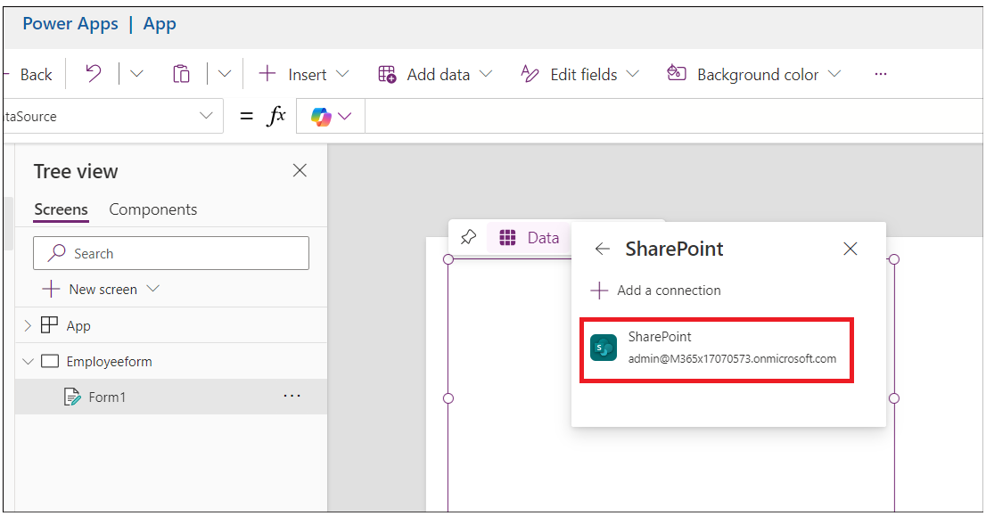

1. Enter the **SharePoint list URL** copied form step 1 into Enter SharePoint URL text field and then click on **Connect**.
2. Under **Choose a list**- >select **Employee Onboarding** list and then click on **Next.**



1. Select **Employee Onboarding** list and then click on **Connect**.



1. Drag and fit the form into the container.

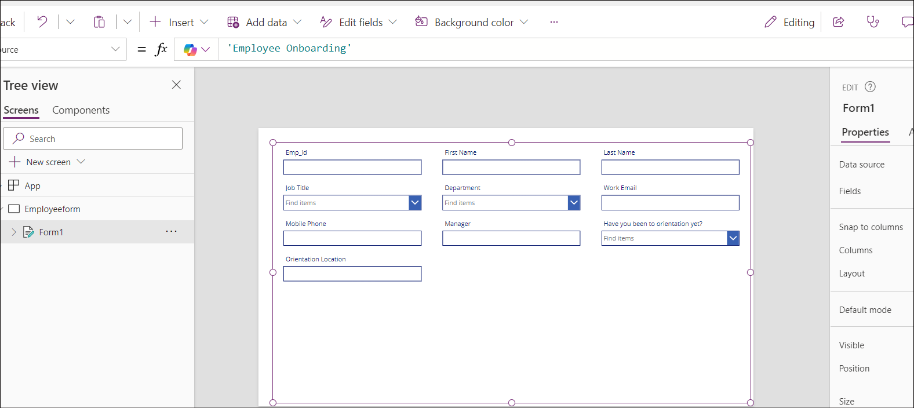

1. Select **Form 1** and **Display** mode to **New** under properties.

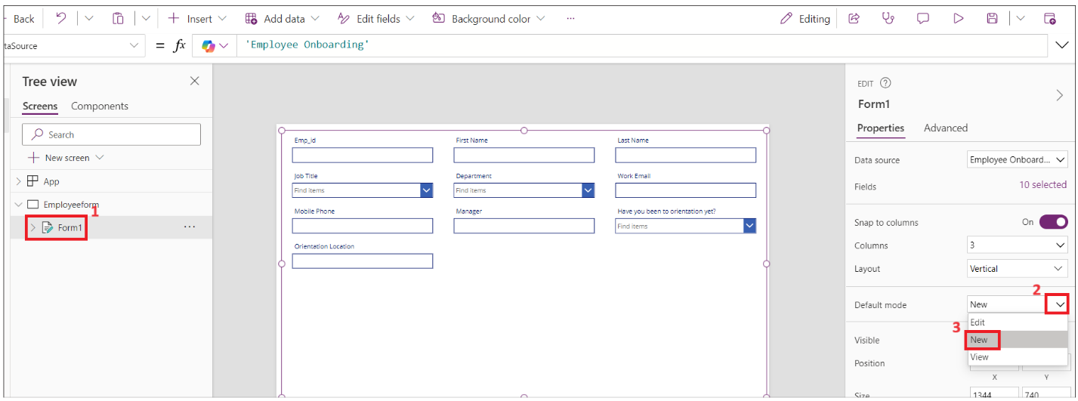

1. Drag the Form1 container little down and click on **Insert- > Rectangle** to insert header to the form.

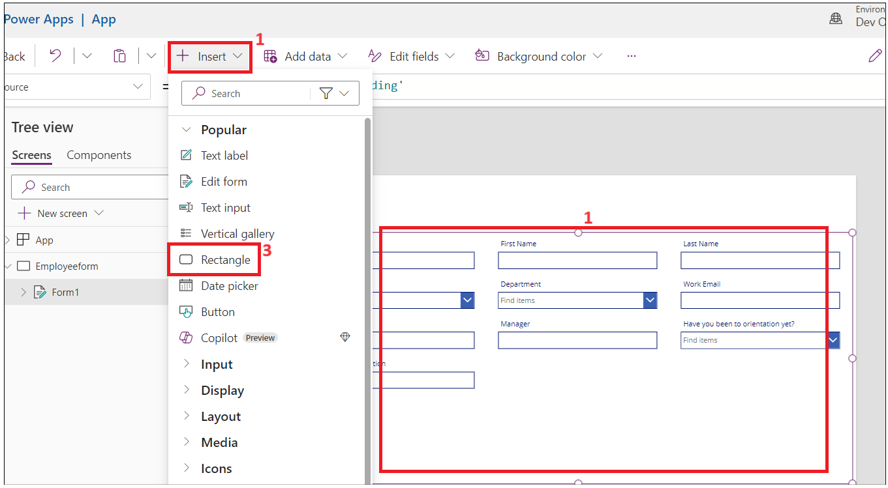

1. Change the width of the rectangle to the container and select **Insert -> Text label**.

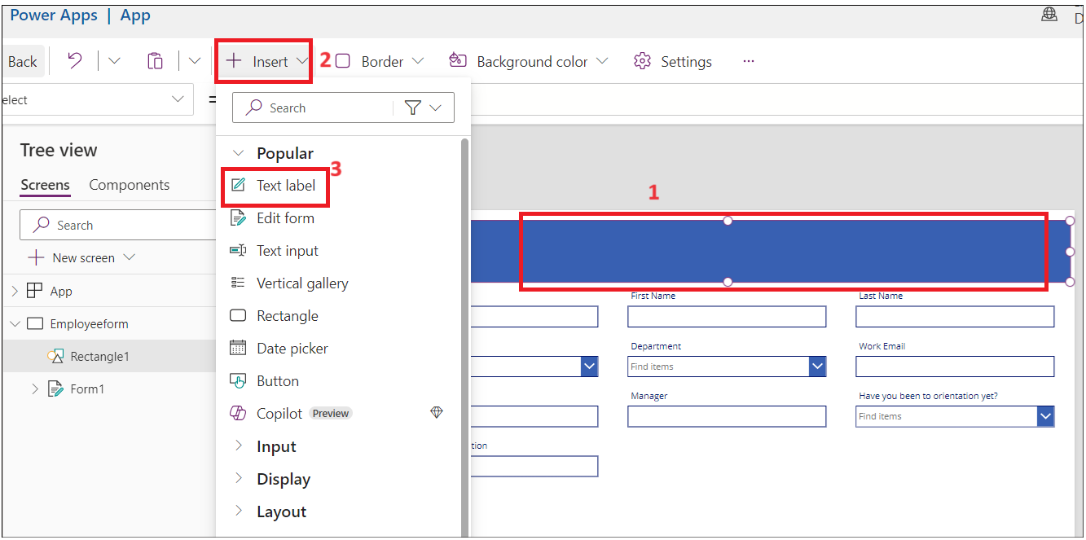

1. Select the Label and set below **properties.** 
   * **Text: Employee Onboarding Form**
   * **Font Size: 25**
   * **Font weight: Bold**
   * **Text alignment: Centre**
   * **Colour: White**

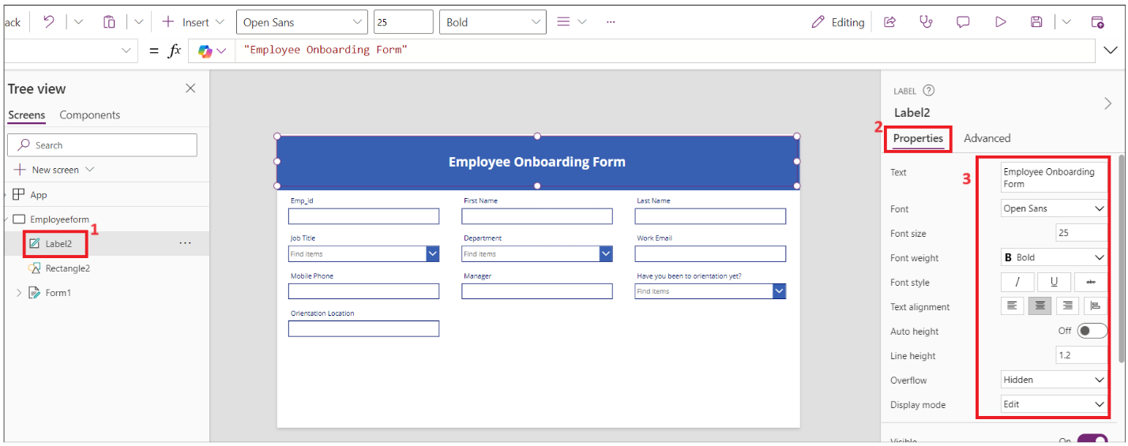

1. Select the **Emp_Id** field name and change **Font size** to **16** and **Font weight** to **Bold** under Properties.

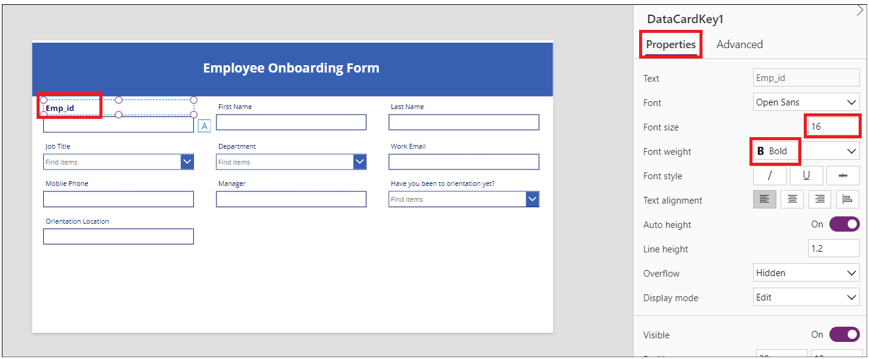

1. Repeat above step for all fields.

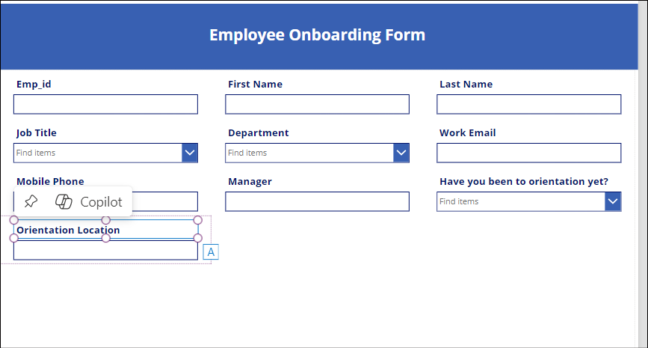

1. Select **Orientation location** item and set **Visible** property to **false.**

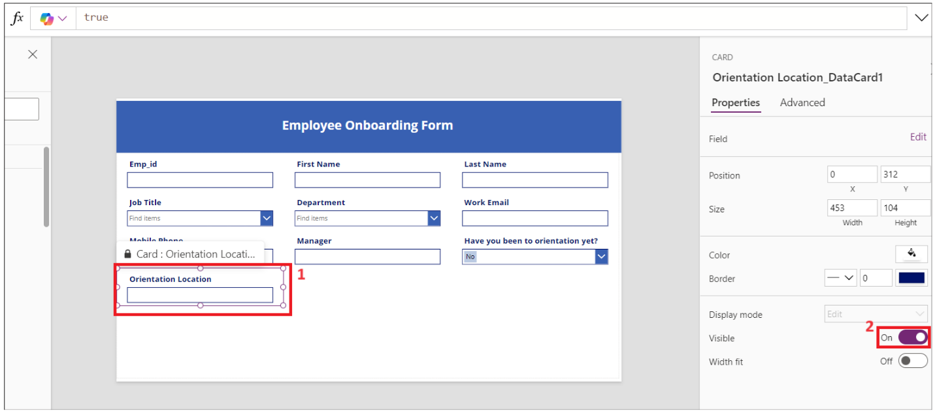

1. Select **Have you been to orientation yet**? text field and click on **edit** label.

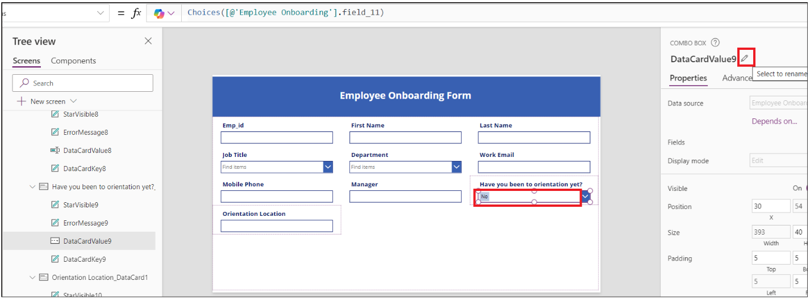

1. Change label value to **Orientationdropdown**

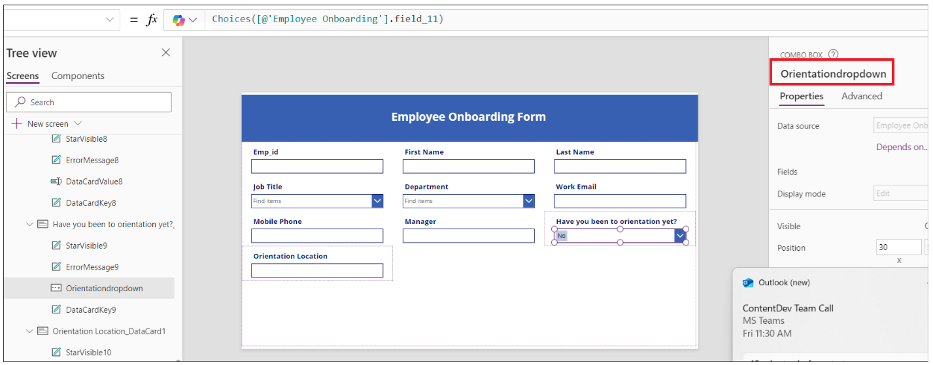

1. Select **Orientation Location data card** and select **Visible** and place below formula as shown in below image.

If(*Orientationdropdown*.Selected.Value="No",true,false)

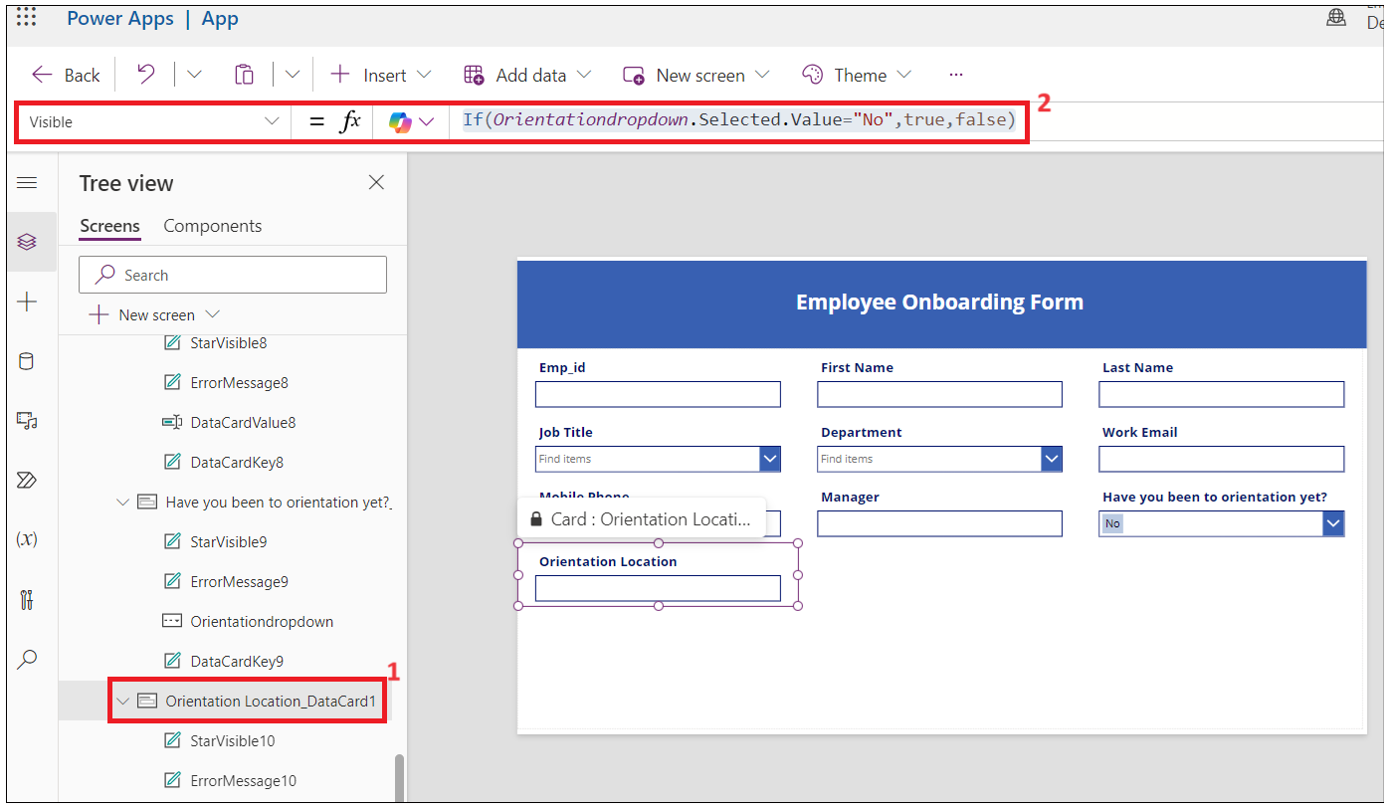

1. Click on **Save** and enter app name as: **EmployeeOnboardingForm** and then click on **Save** button.

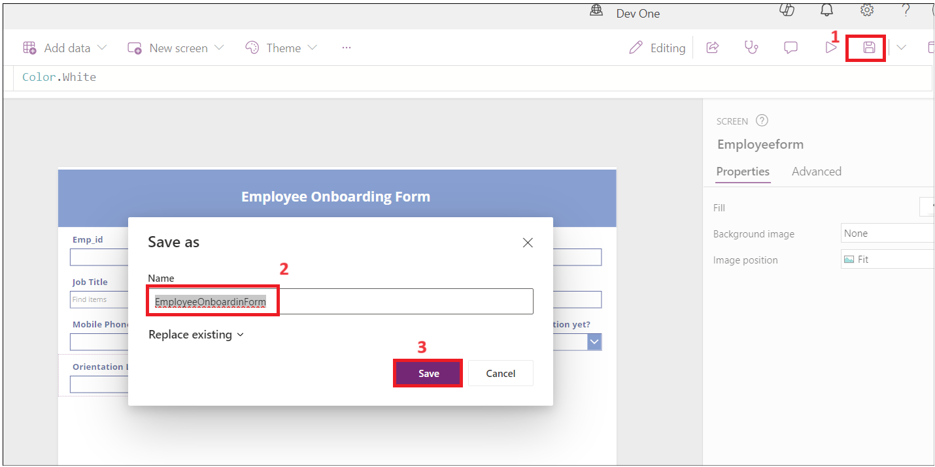

1. **Emp_id**, **First Name**, **Last Name** and **Manager** will be filled by HR, so change the display mode to **View**.
2. Select the field and click **on Advanced-> Unlock to change properties** and update **Display mode** to **Parent.DisplayMode.View**

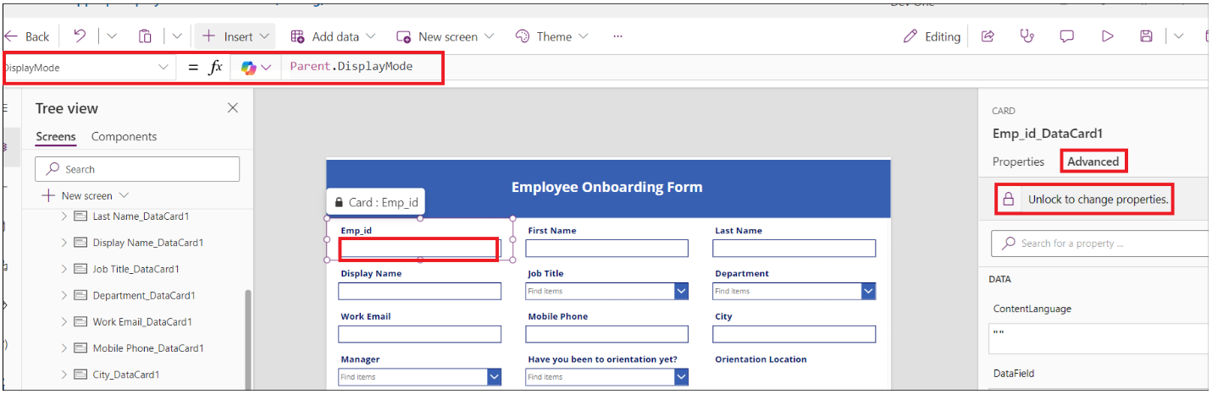

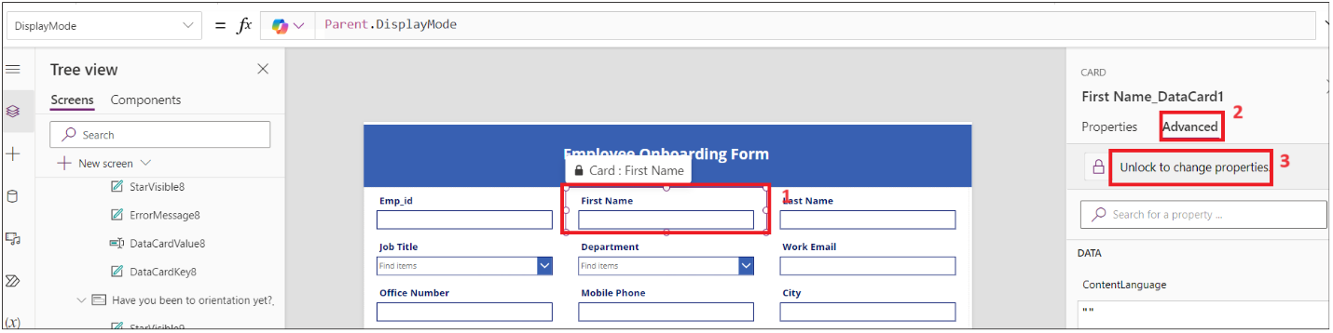

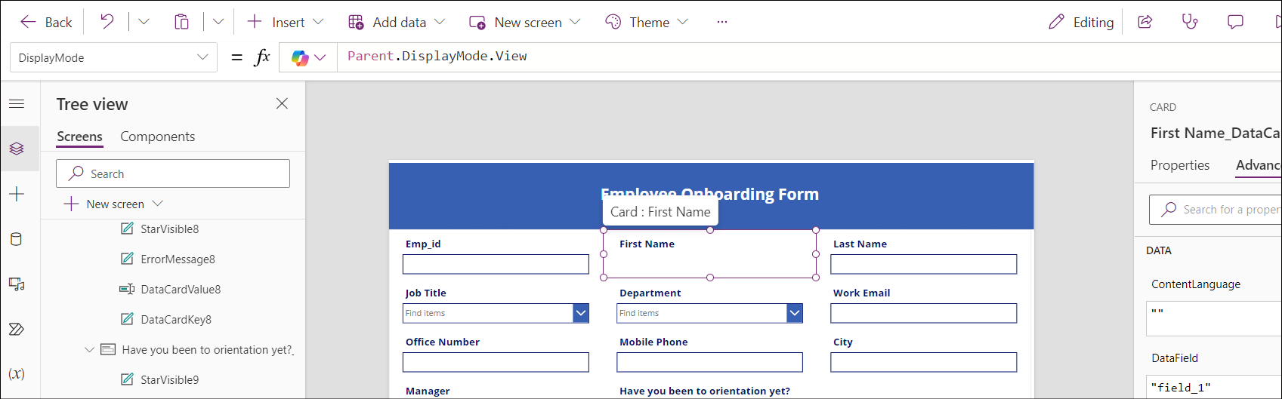

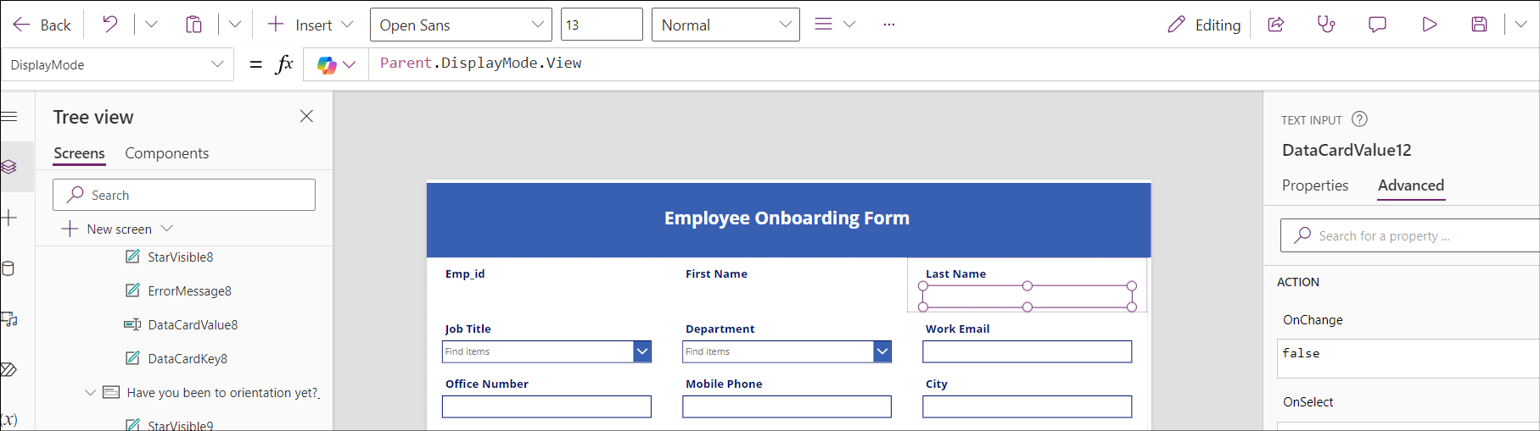

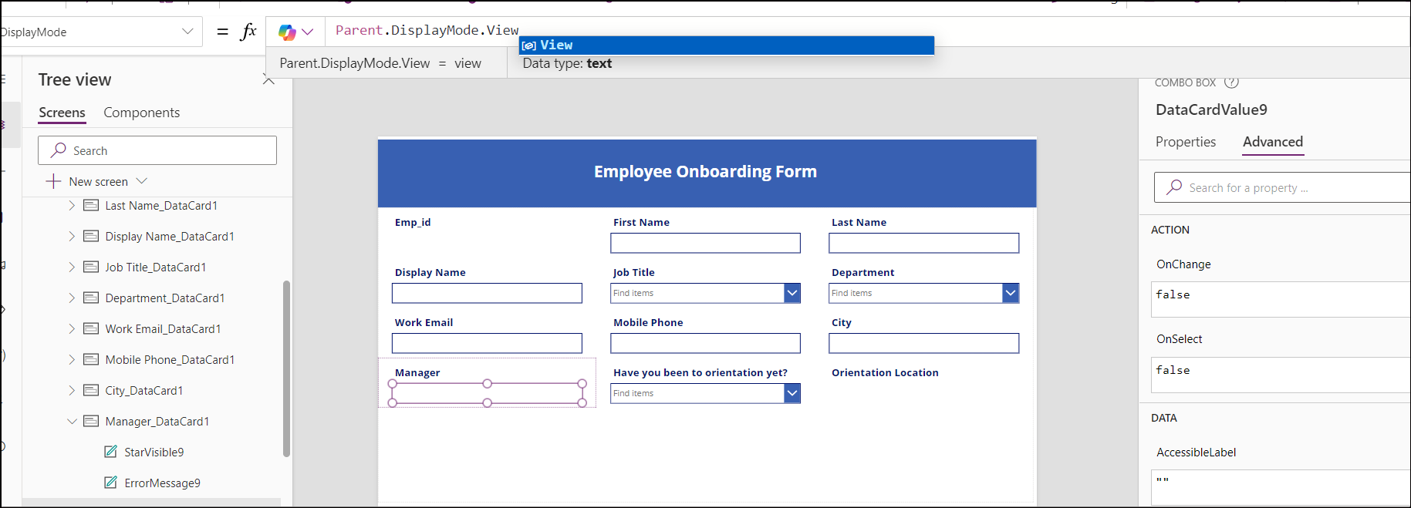

1. Select the **Work email** Field -> **Unlock property** and update **Required** property to **true.** Repeat for other fields if required.

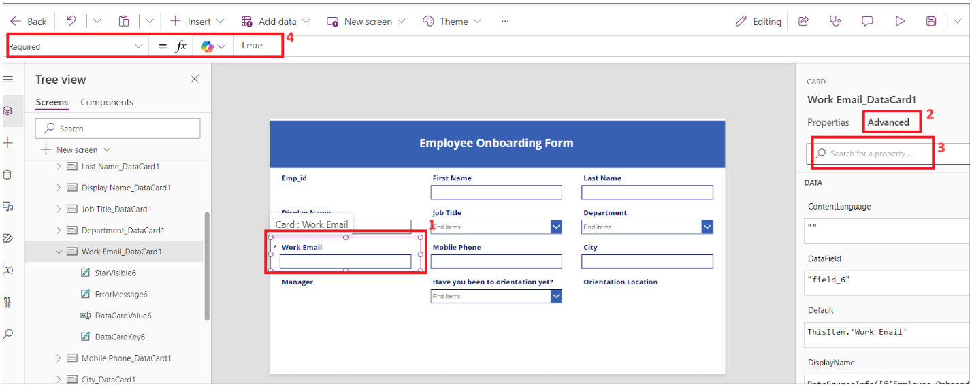

1. Select the **Form1** and update **OnFailed** field value to

Notify("Required Fields can't be empty.",NotificationType.Error)

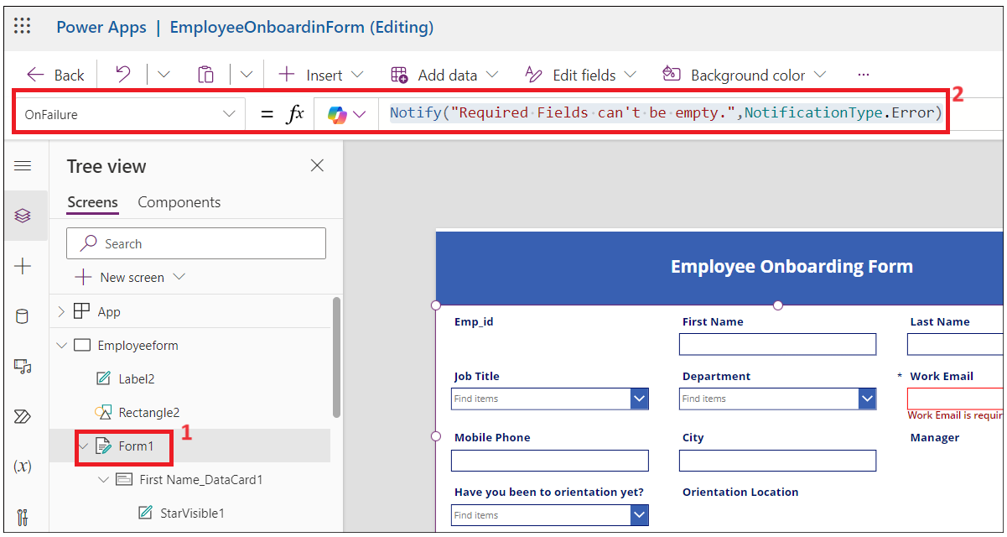

1. Select **OnSuccess** and set the value to

Notify("Thank you for filling out the form",NotificationType.Success)

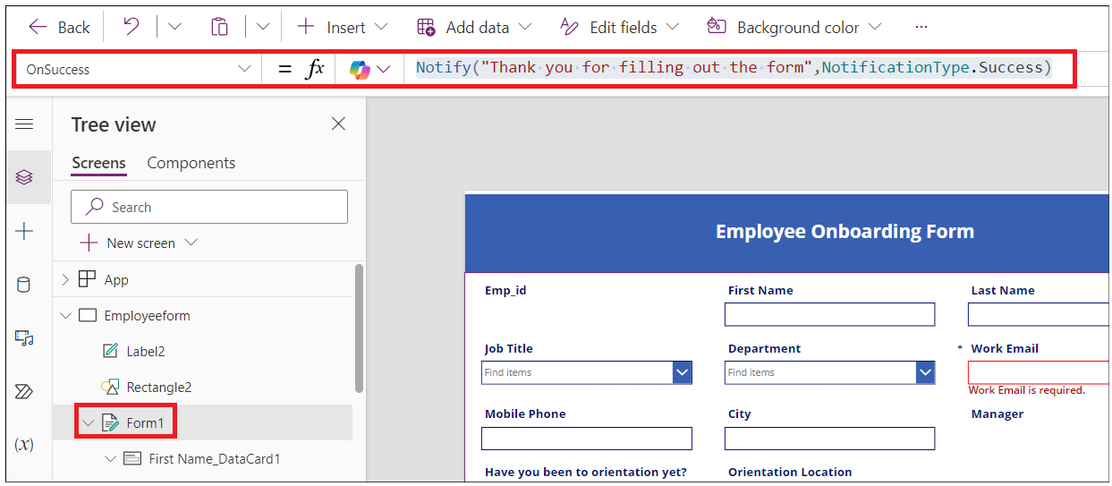

1. Now, Let’s add button to submit at the end of the form. Click on **Inset- > Button.**

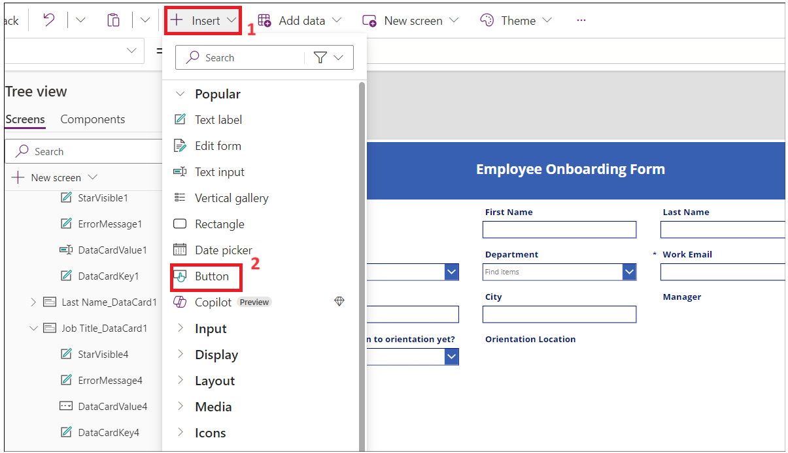

1. Change the Properties of the button and save the form.
   * Text -> **Submit.**
   * Onselect: **SubmitForm(*Form1*);NewForm(*Form1*)**

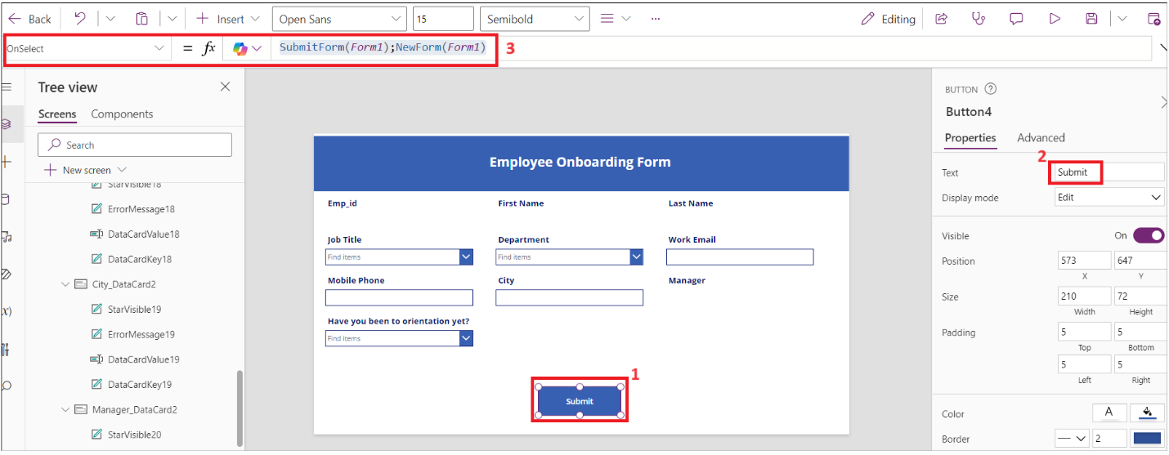

1. Click on **Save** and then click on **Preview** app buttons.

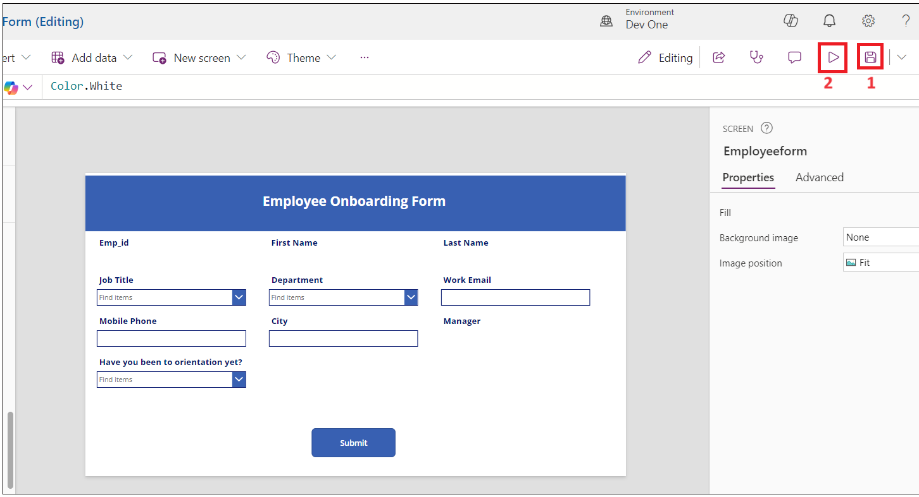

1. Enter details and then click on **Submit**.

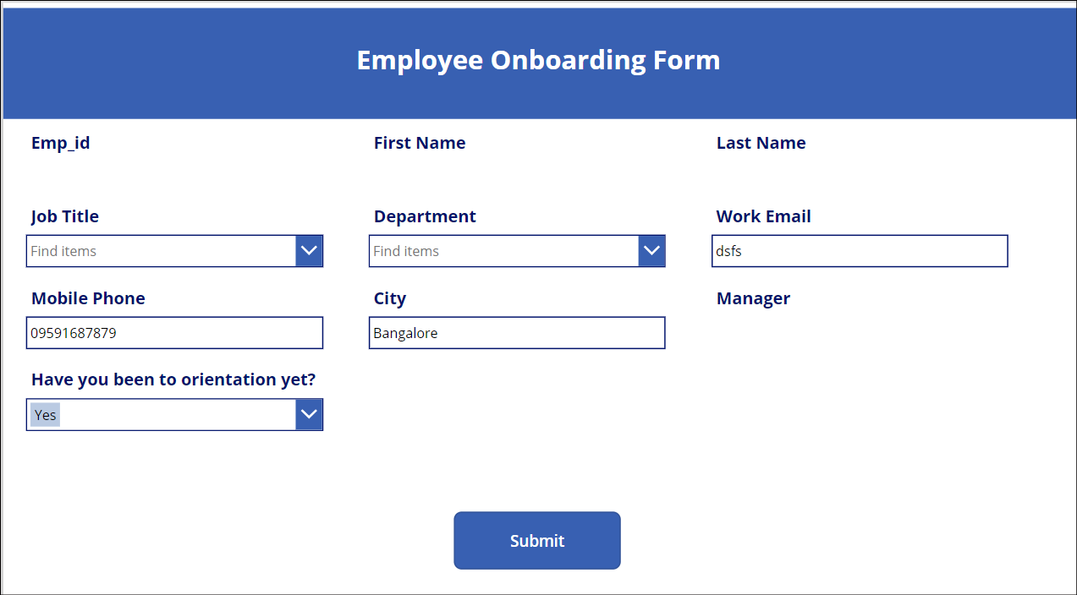

1. You should see success notification.

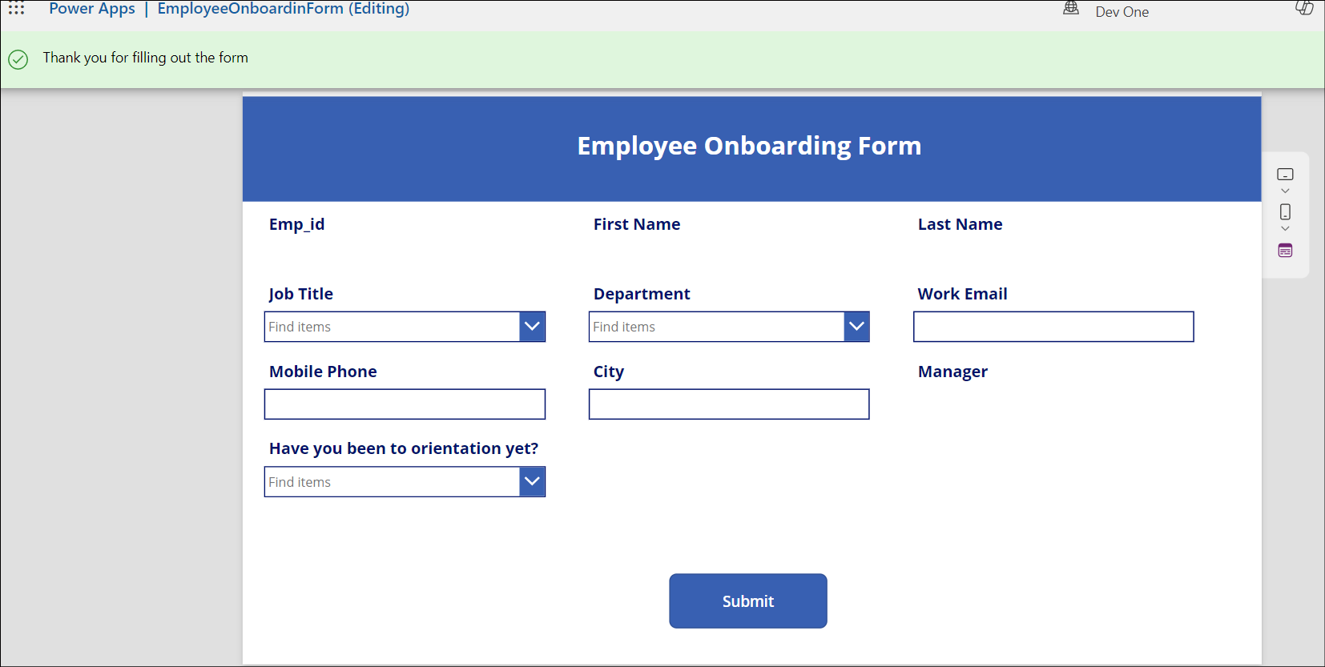

1. Close the preview window.
2. Click on **App** from **Tree View**. Select **OnStart** and enter the below formula.

Set(

    onboardinglistitem,

    LookUp(

        'Employee Onboarding',

        ID = Value(Param("ItemID"))

    )

)

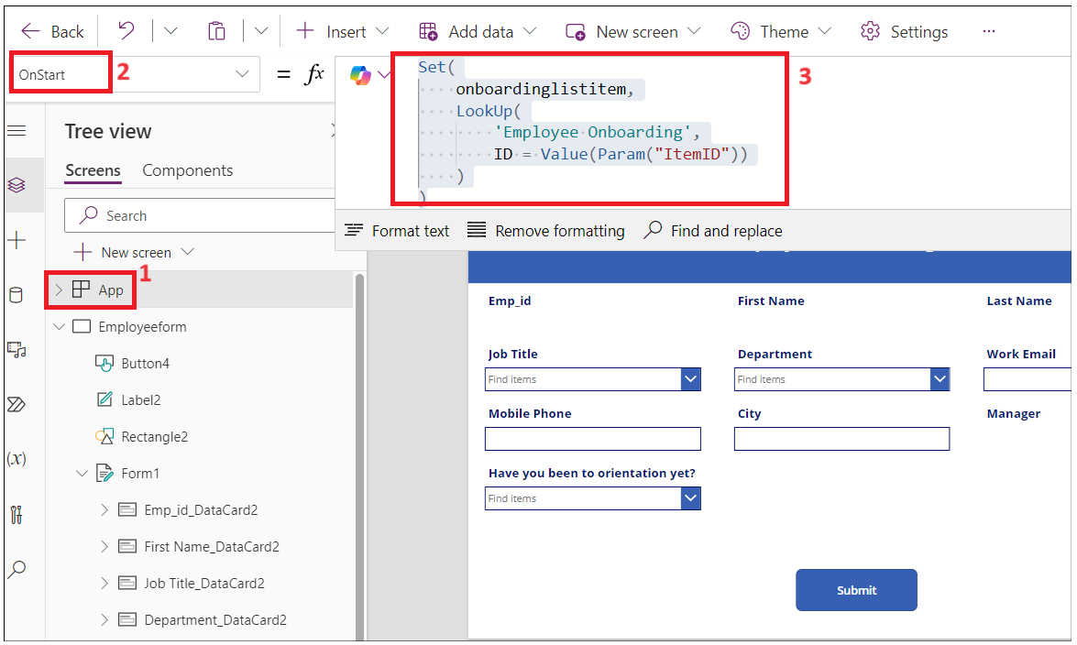

1. Select the **Form1** from **Tree View**. Select item and enter the value as: **onboardinglistitem**

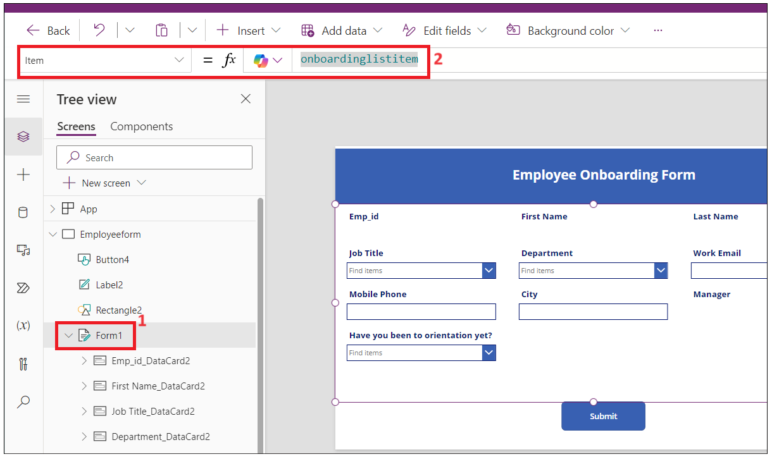

1. Click on **Save** and **Publish -> Publish this version**.

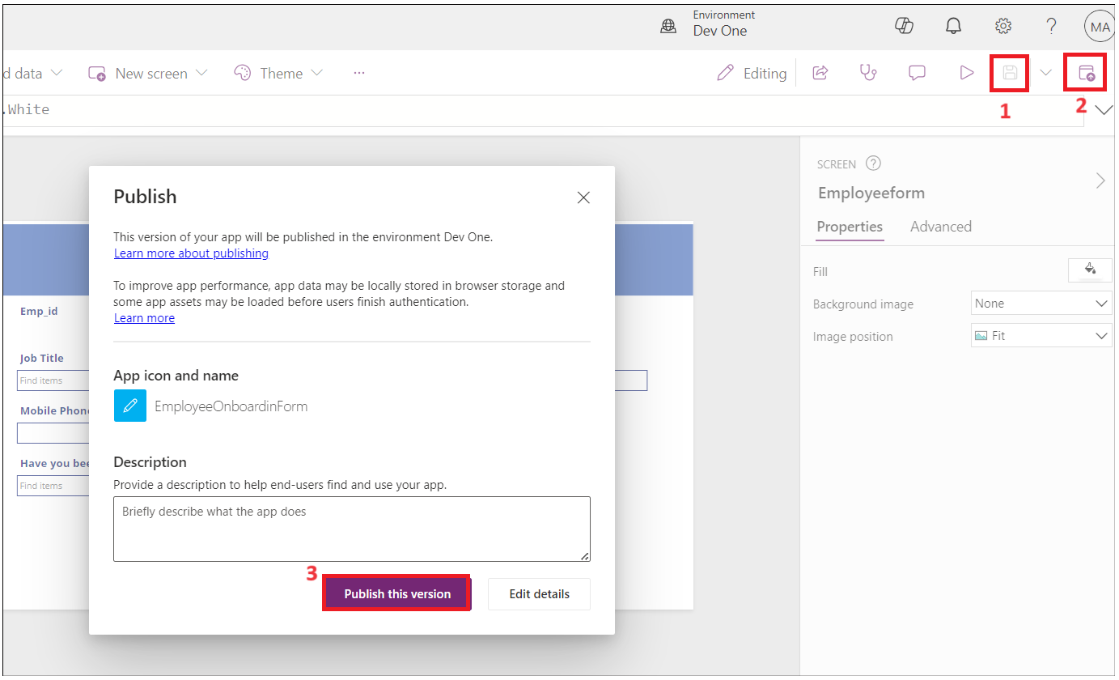

1. Go back to the **Power Apps Home** page, Click on **Apps-> Your app-> Details**.

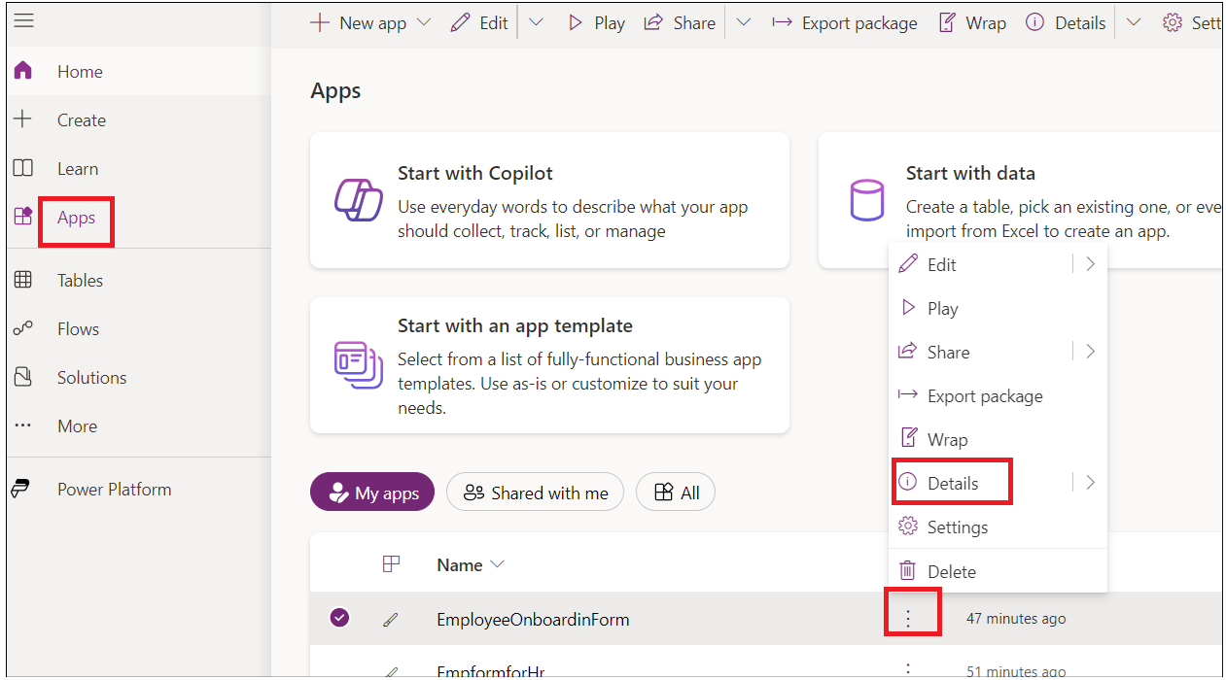

1. Copy the Weblink to use in next task.

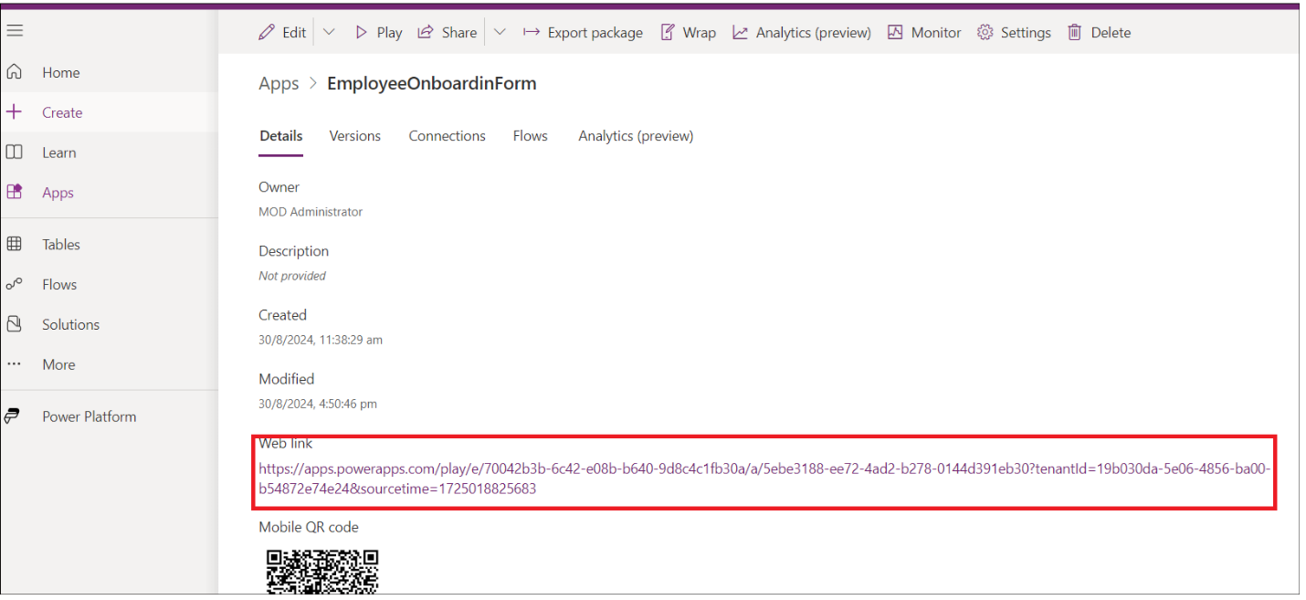

1. Close the preview window and navigate to your SharePoint tab and check the above record in the list.

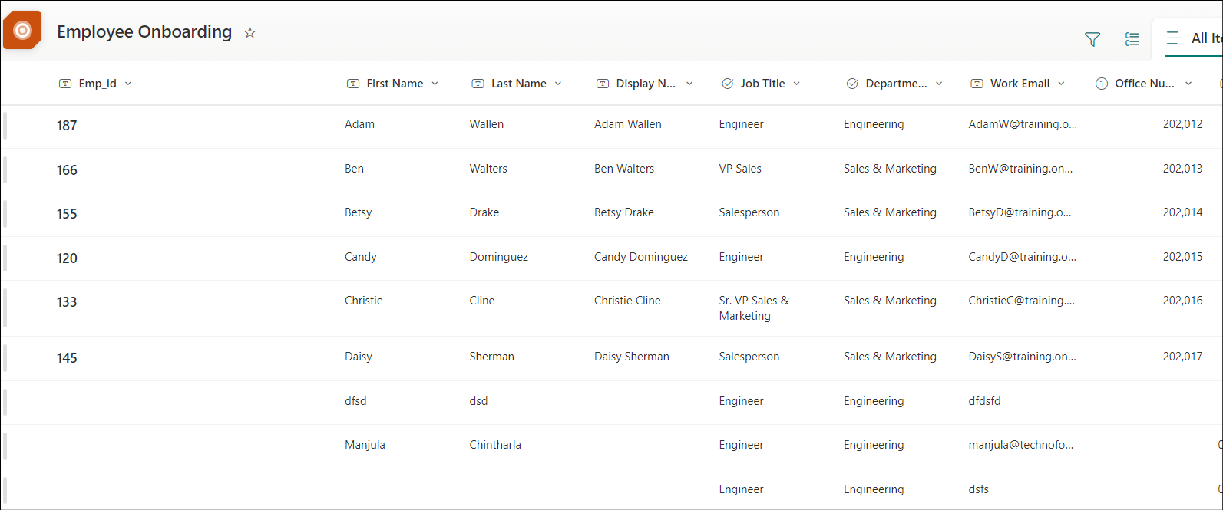

## Task 3: Create Power Automate flow to send a form to the new employee

1. Go back to **SharePoint** tab and copy the URL.

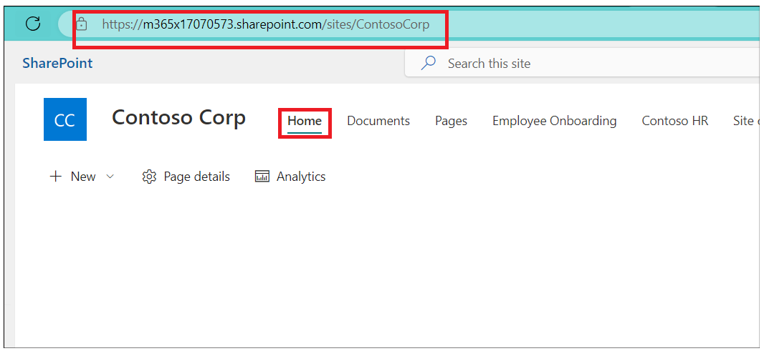

1. Open a new tab and go to https:\\flow.microsoft.com and sign in with your admin tenant account**.**
2. Select your **developer environment**.
3. Click on **Flows** from left navigation menu**.** Click on **New Flow-> Automated Cloud flow.**

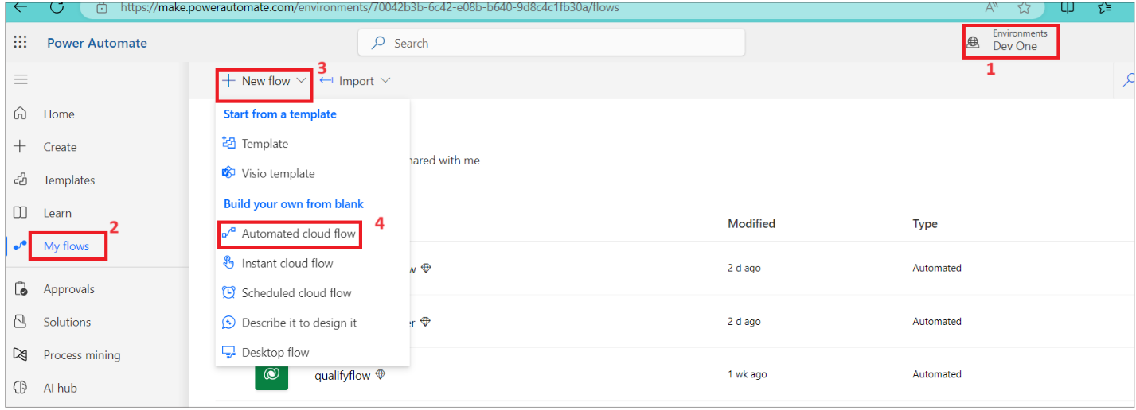

1. Enter the flow name as: **Onboarding new employee**. Searchfor **When an item is created** and select it from SharePoint and then click on **create**.

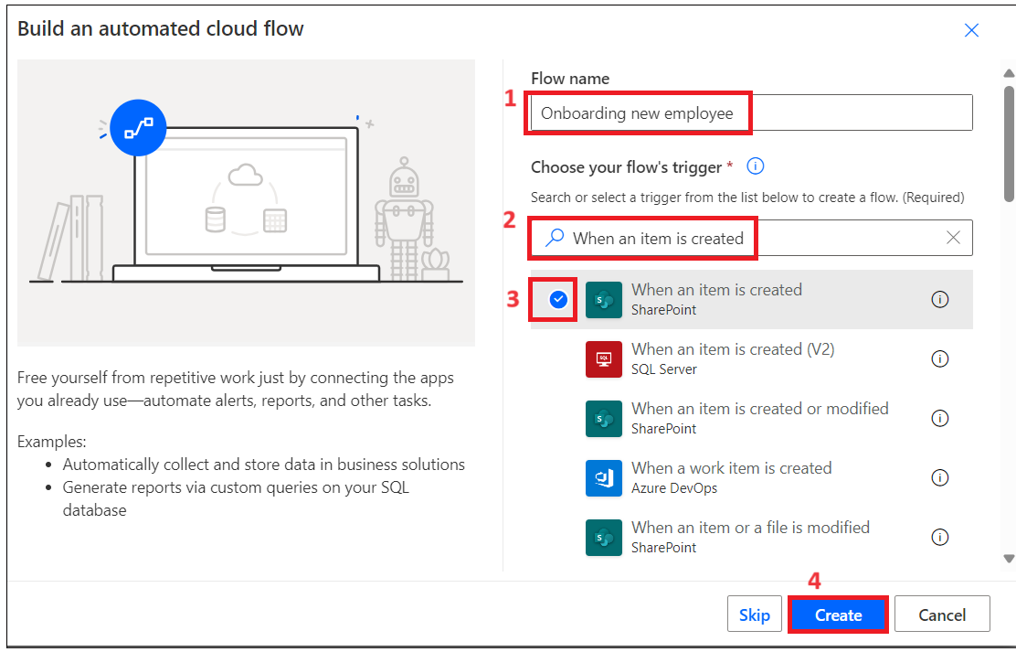

1. Select the action. Click on **Site Address -> Enter custom value.**

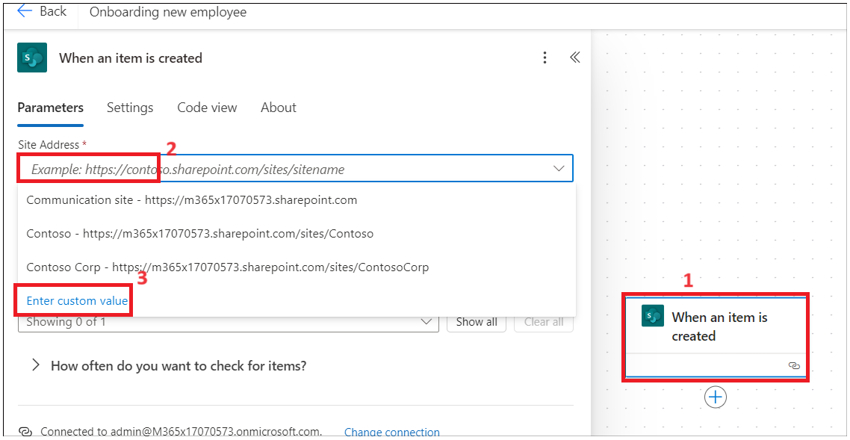

1. Enter the Address copied in Step 1 and then select the **Employee Onboarding** list as shown in below image.

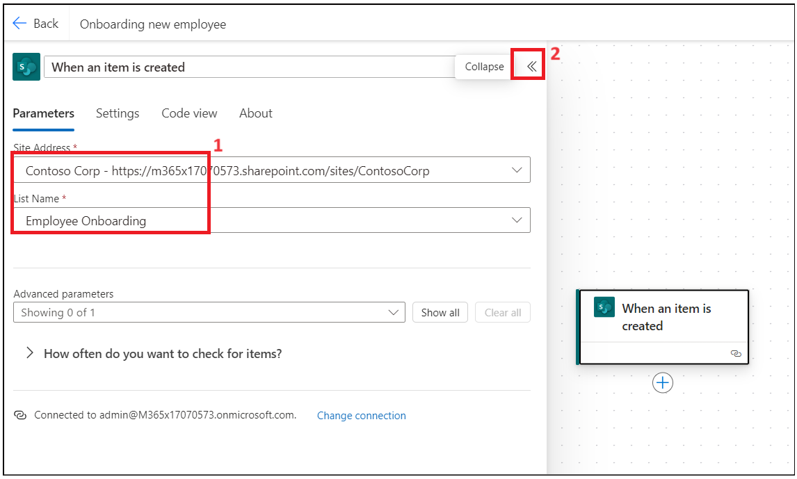

1. Click on + to add new action.

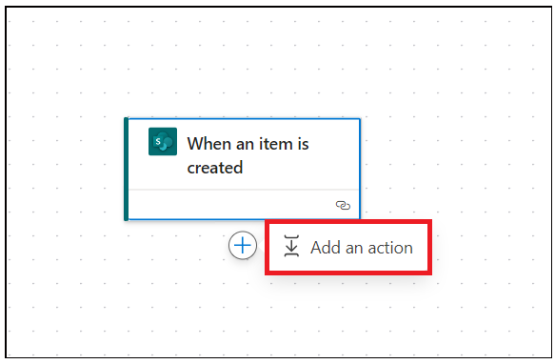

1. Seach for and select **Send an email (V2)**

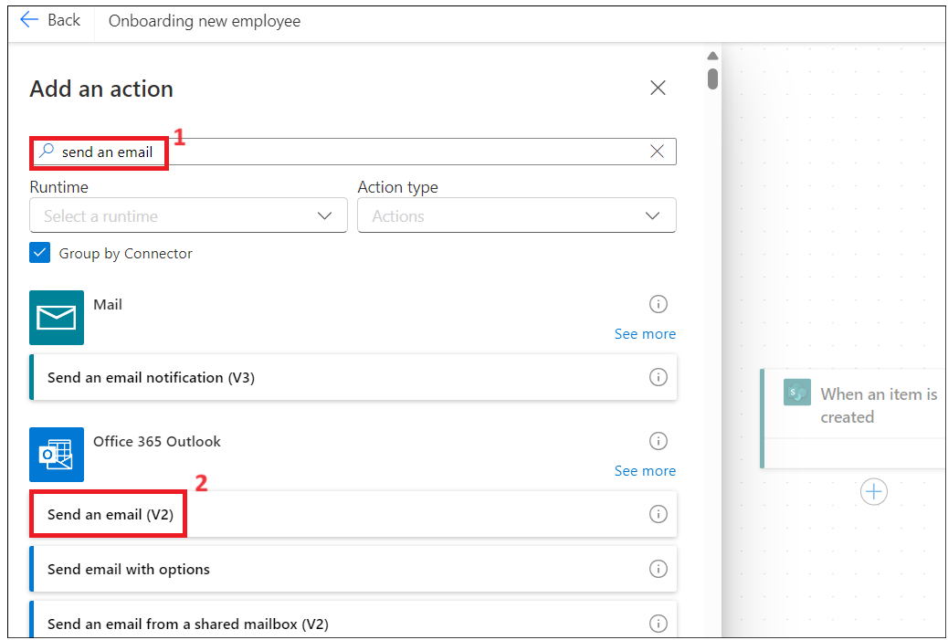

1. Click on to text field and select **Enter the data from previous step**.

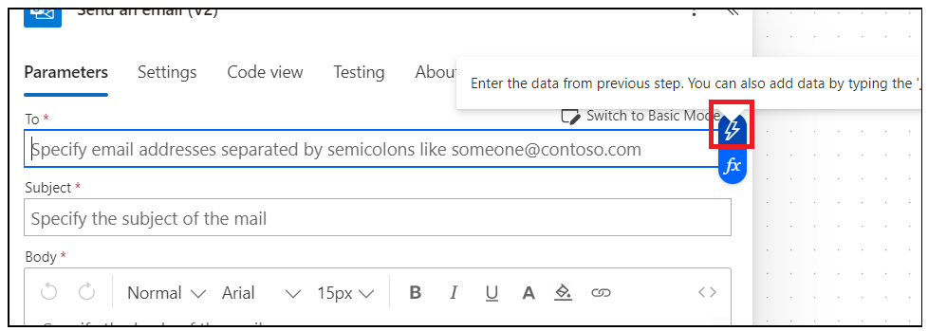

1. Select **Work email.**

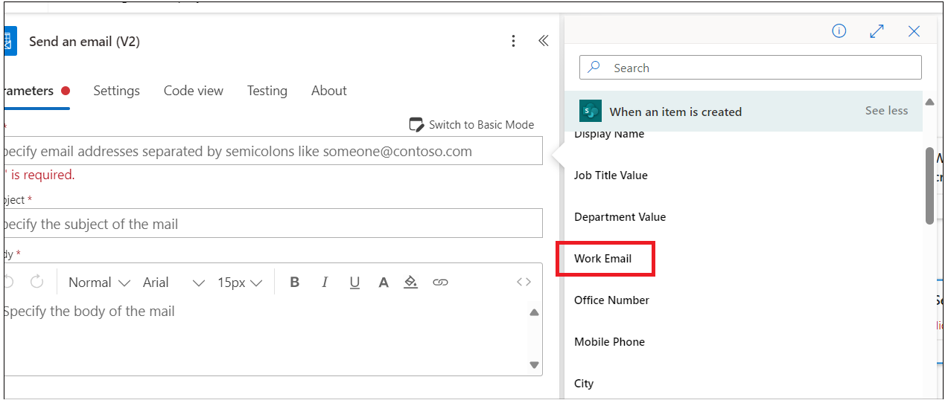

1. Enter the Subject line as: **Welcome to Firm** select **First Name** from previous step.

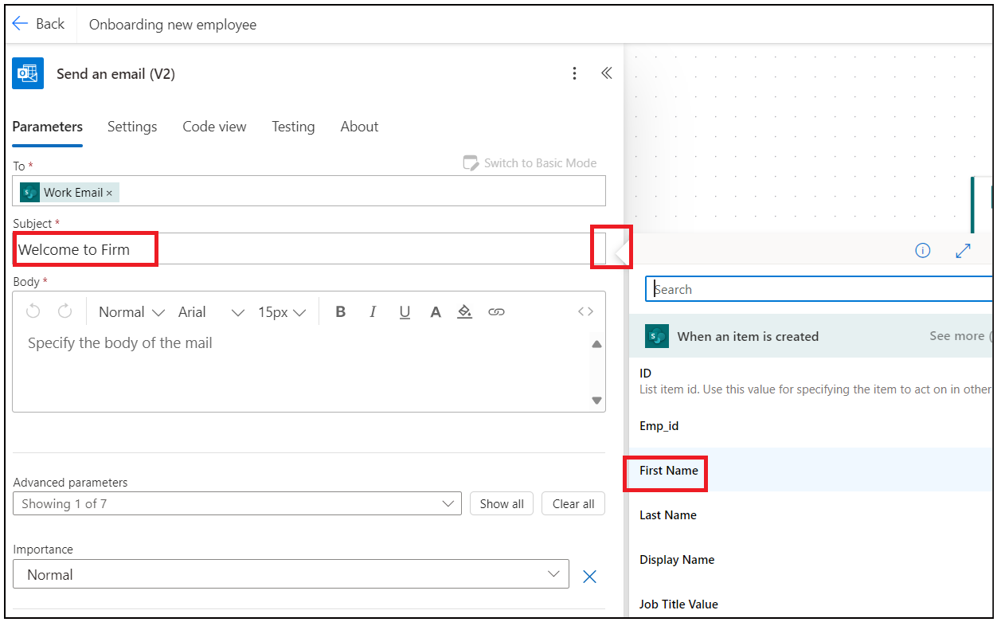

1. Enter below data in Body of the email. Insert dynamic values as shown in image.

Hi first name Lastname,

Please click on link below to complete your onboarding form.

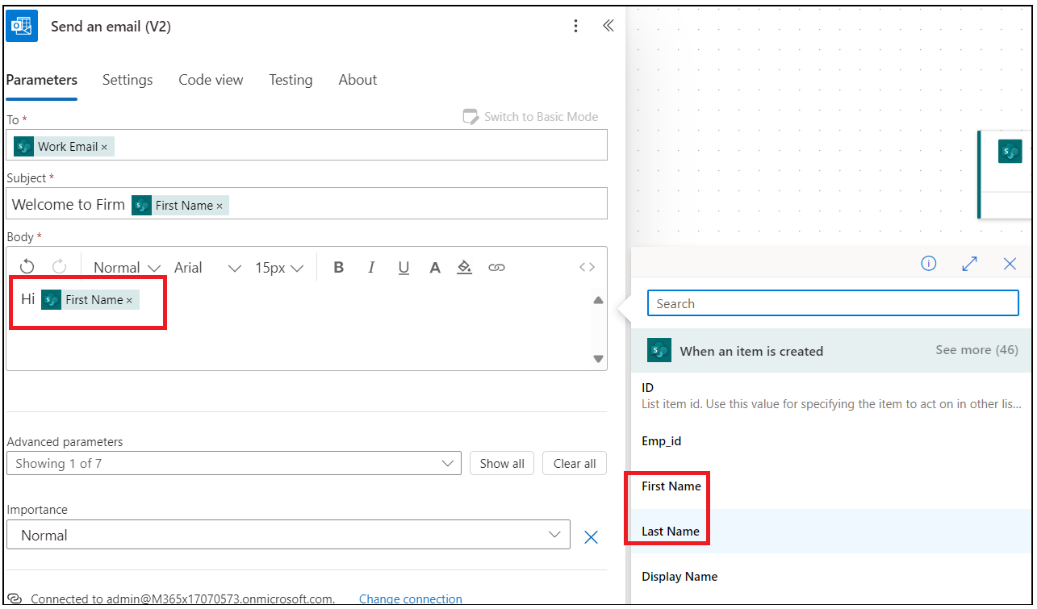

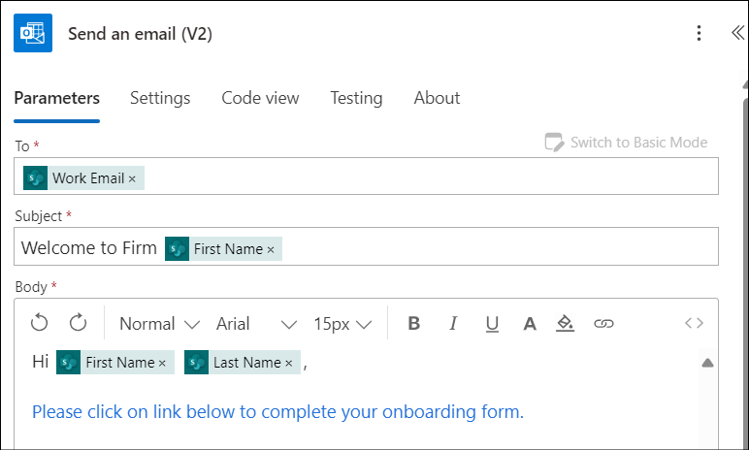

1. Enter the Weblink copied in Task 2 – and add **&itemID=** at the end of the link and select Dynamic ID as shown in below image.

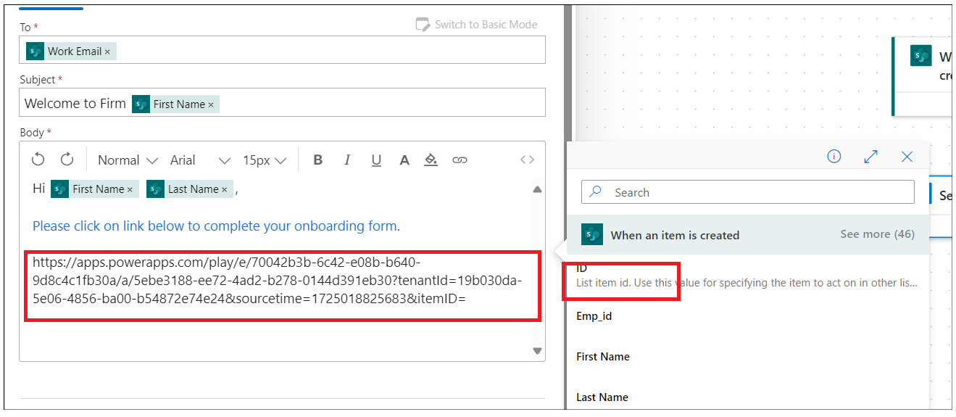

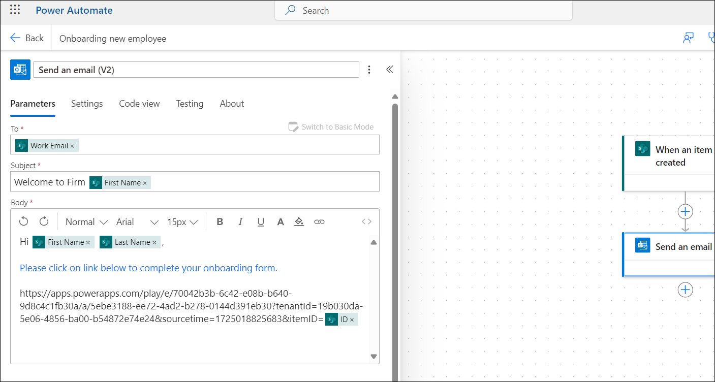

1. Cut the link and then enter the text: **Onboarding Form** and select and click on link icon. paste the link copied from above step.

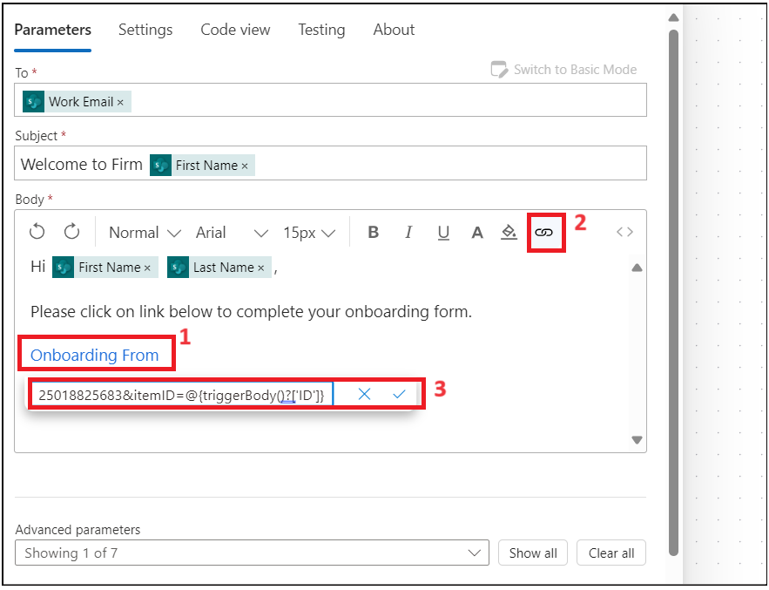

1. Save the flow now.

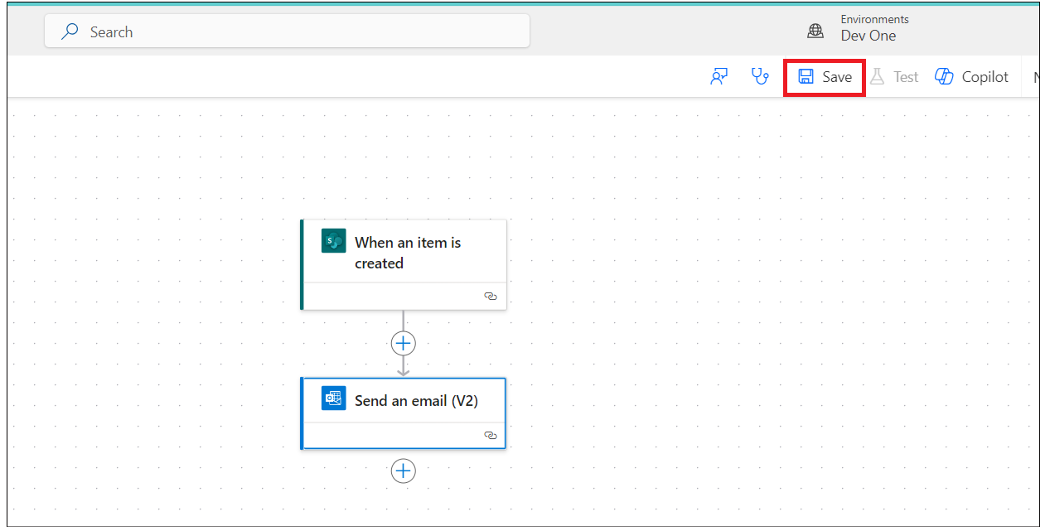

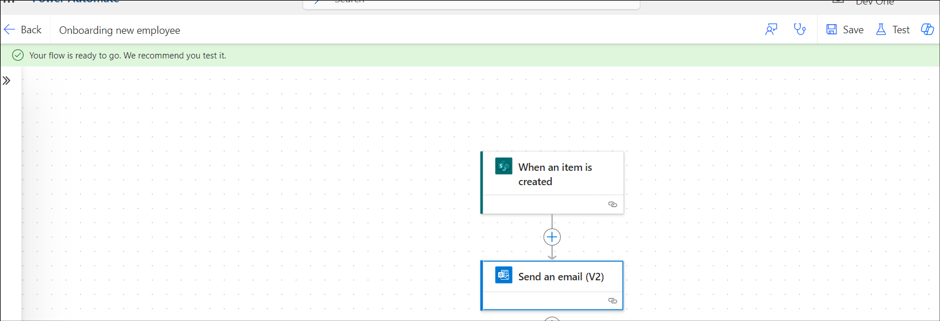

## Task 4: Test the flow.

1. Go back to **Power Apps tab**, select **EmpformforHr** app.

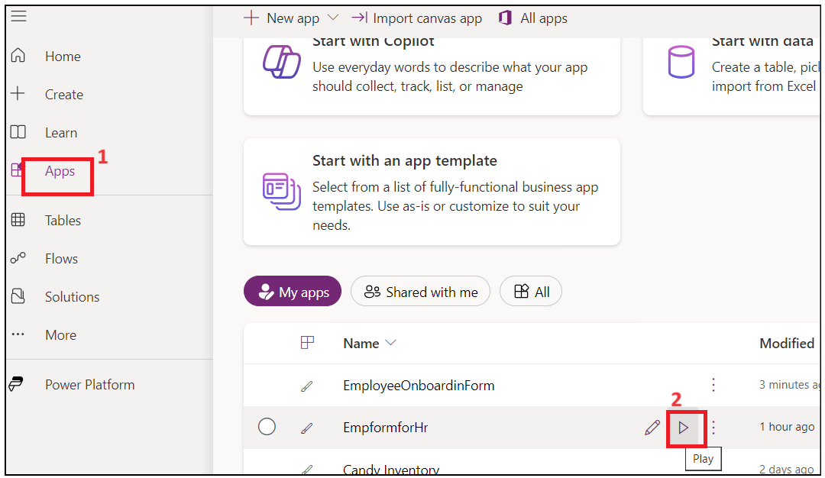

1. IF asked then allow permissions.

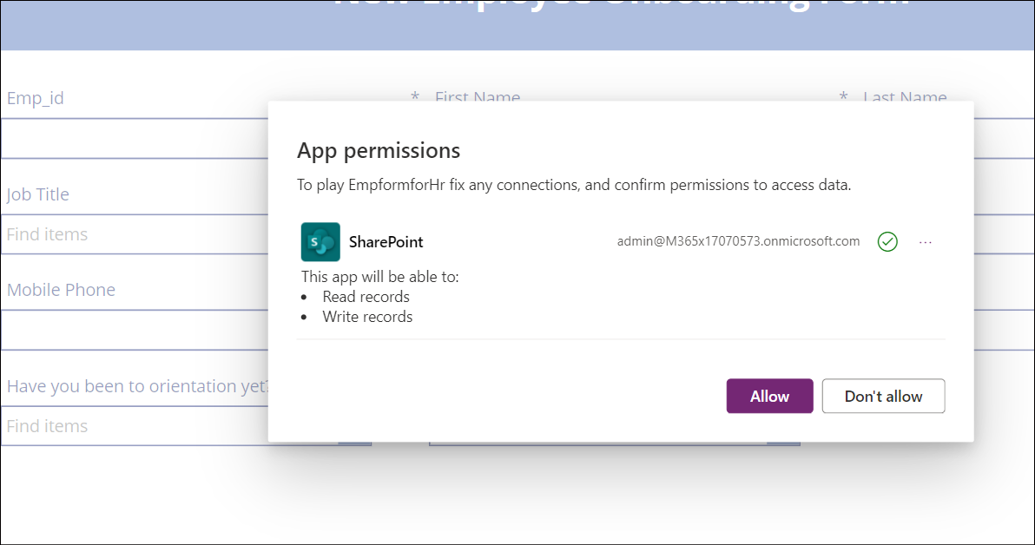

1. Fill the form with your details. Enter work email as your admin tenant id and **submit** the form.

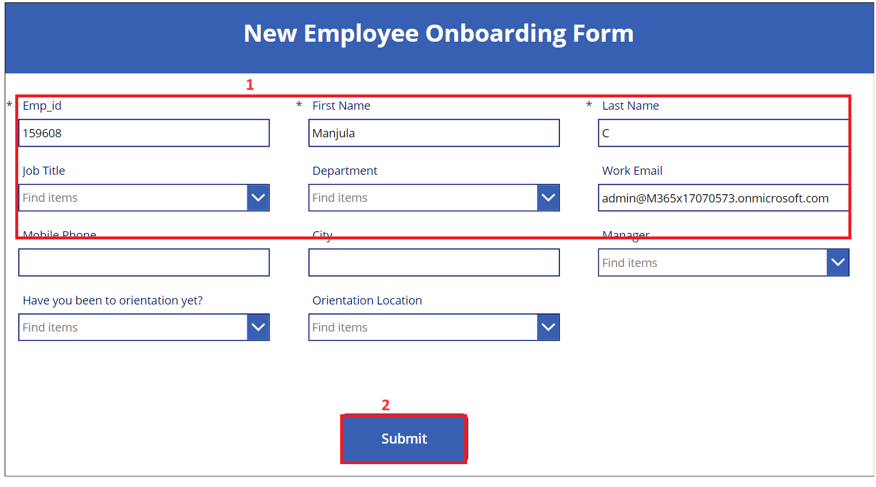

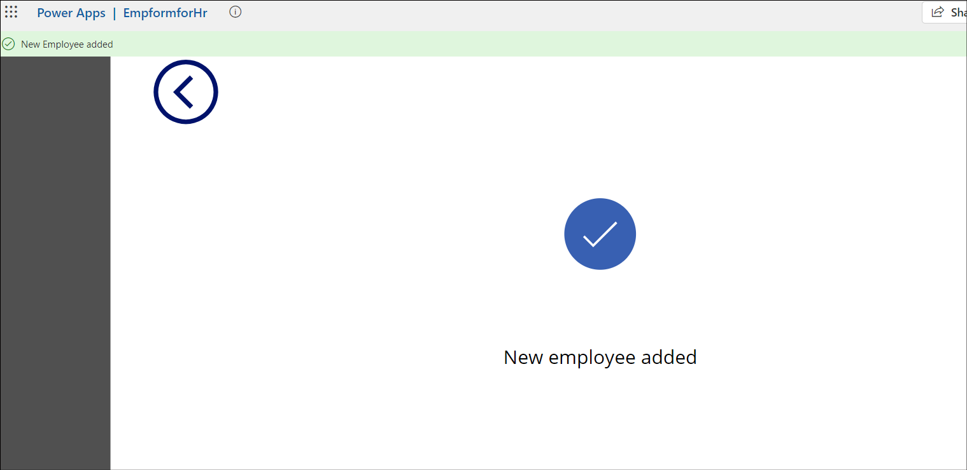

1. Go back to the Power Automate flow and check flow Status.

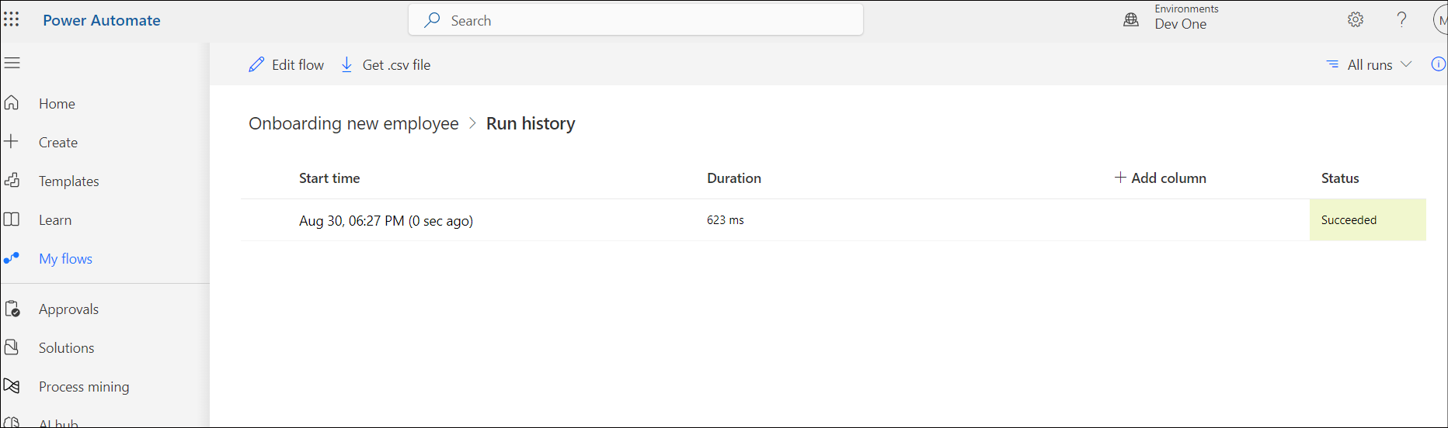

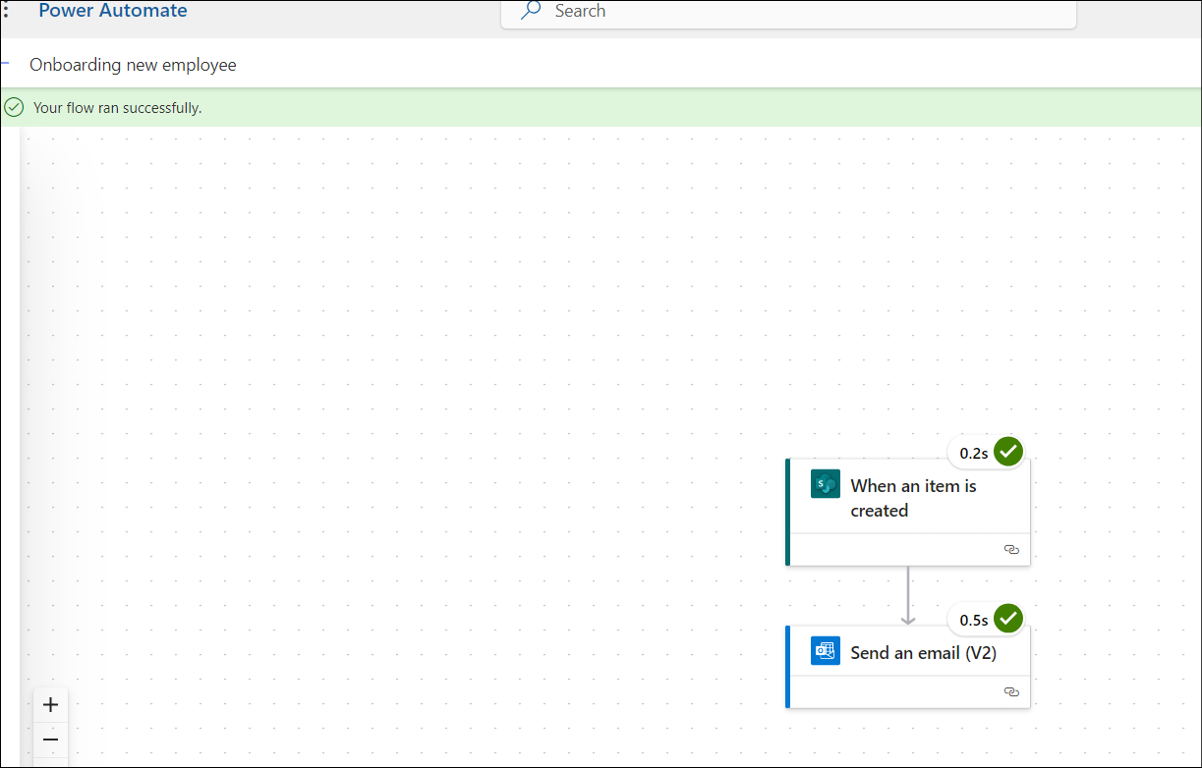

1. Open a new tab and go to https:\\outlook.com and sign in with your O365 admin account and check inbox. Click on the **Onboarding Form** link in the email generated from HR.

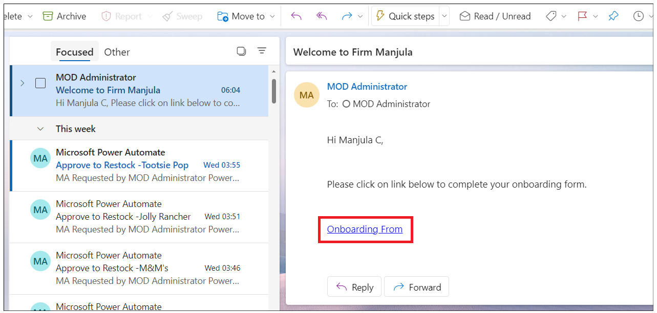

## Conclusion

After completing this exercise, you will have:

1. **Employee Onboarding app using Power Apps**

This app streamlines the employee onboarding process, providing a user-friendly interface for new hires to complete necessary tasks, submit required documents, and access important information. It helps manage and track the onboarding steps to ensure a smooth integration into the company.

1. **Power Automate cloud flow to generate an email to employee to complete Onboarding process.**

This flow automatically generates and sends an email to new employees, prompting them to complete their onboarding process. The email includes instructions and any necessary links or documents to facilitate a seamless onboarding experience.